**NATIONAL RESEARCH UNIVERSITY HIGHER SCHOOL OF ECONOMICS,**

**ST. PETERSBURG**

**ST. PETERSBURG SCHOOL OF ECONOMICS AND MANAGEMENT**

**DEPARTMENT OF MANAGEMET**

**RESEARCH PROPOSAL**

**Impact of Covid-19 on Commodity prices. Box-Jenkins Method**

Dmitry Krutogolov, group №201

Research Advisor:

Makarova V.A., Associate Professor

Linguistic Advisor:

Department of Foreign languages

ST PETERSBURG

2021

## **Abstract**

This article discuss how the forecast of commodity prices changes depending on the forecasting method in the framework of the Box-Jenkins approach. The results of the article are focused on companies in the extractive industry. Using a model that is appropriate for a particular type of raw material will allow for more accurate predictions and reduce errors associated with the wrong choice of the model., This paper is about applicability of ARIMA and SARIMAX models on commodity prices in case of crisis such as Covid-19 pandemic, and how good these methods could be applied for raw materials prices prediction. In our work we discovered prediction for 16 various types of raw materials from fourth basic groups: precious metals, non-metals metals, metals, energy carriers. We justify that those methods are not applicable on such volatile data as most part of raw materials from our selection.

Key words: Raw material, metals, oil, ARIMA, SARIMAX, forecasting, Box-Jenkins method

**Table of Contents**

**Abstract** 1

**Part 1. Literature review** 5

**Logic of Research** 5

**Energy carriers** 6

**Non-Ferrous Metals** 9

**Ferrous metals** 10

**Precious Metals** 11

**Methods of forecasting.** 13

**Pandemic** 13

**Box-Jenkins method – ARIMA modeling** 14

**Problems of ARIMA** 15

**Moving to SARIMA** 15

**Methods of defining models: Dickey-Fuller test and Akaike information criterion.** 16

**The quality of predictions** 16

**Applying of forecasting algorithms** 16

**Part 2. Data and Methodology** 19

**Data collection** 19

**Beginning of crisis** 21

**Train-test splitting** 21

**Stationarity or Seasonality** 21

**Box-Jenkins realization** 23

**Methods of comparing models.** 24

**Practice realization** 25

**Discussion** 27

**Conclusion** 32

**References** 34

**Appendix** 38

**Introduction**

For many reasons raw material price volatility has increased in 2020. The authors attribute the increase in volatility to the uncertainty that arose due to the 2020 pandemic. Many papers are written about which parameters influence on commodity prices, some of them include corona-virus infection. Some works are written about Box-Jenkins method too.

In this paper we applied Box Jensen's method to predict commodity prices. Boxing-Jenkins, constantly evolving. However, only a few papers are written about Jenkins and SARIMAX and their applicability to such a volatile date as raw materials, and we wanted to expand its use. moreover, there is a pandemic here, and this is a very good reason to try it. The interest in these methods is due to the current changes in economic processes associated with the epidemic. In resource-producing countries such as Russia and the Caucasus, which are rich in natural resources, the crisis mainly affected the commodity and because of it - financial sector, due to the inertia of their economies and their one-sided integration. (Lola, S. and Albina, G. (2009))

This paper could be useful for management of large trading companies, raw materials producers and other ones, who are interested in making money on volatility of raw materials, and if Box-Jenkins method is useful for prediction of prices, that will improve their activity. It can be another powerful instrument. Raw material buyers need an analytical framework that is versatile enough quickly to adapt to new circumstances.

Companies that plan future activities usually face problems with the forecast values of basic development indicators, such as revenue, sales volume, cost of goods produced, and so on.

The authors note that this problem is directly related to the ability to predict the prices of current assets for the future period. Typically, companies use the following methods to predict prices:

Right now, most of the forecasting methods depends on the data we have:

1. Predicting the probability of a trade (binary probability models, or logit regression).
2. The length of the sales cycle (turnover of an item).
3. Intuitive forecasting (expert opinion).
4. Historical analysis method or rollover (simple time series analysis).
5. Multivariate analysis (multinominal regression).
6. Sales funnel analysis.

For example, the price of gold has a strong seasonality and reacts to the growing uncertainty of the financial market. At the same time, the dynamics of silver does not allow us to identify patterns in the formation of prices.

According to this resource companies relies on productivity of managers forecasts. Most forecasts are based on historical prices. Forecasting is about reducing the forecast error. however, if the historical data is not suitable for making forecasts using common methods, the error will be high, and the forecast will not be relevant. the study will help to set prices at a relevant level and develop a system of discounts for potential buyers depending on the market situation.

So, research questions can be formulated like this:

1. Is it possible to apply ARIMA models in conditions of high uncertainty?

2. Does Box-Jenkins method good for creating forecasts?

3. Can it be applied for commodity prices prediction?

4. How shifts commodity prices prediction factors according to worldwide natural disaster – corona virus?

# **Part 1. Literature review**

Structure of this paragraph. First section is about raw materials, which factors have an impact on it in normal situation, second one discloses Box-Jenkins, SARIMAX methods and information how it works.

According to the UN report in March 2020 when the pandemic begin in the whole world, Free Market Commodity Price Index lost 20.4% (In January 1.2 and 8.5 in February). Fuels were the main driver behind this, recording a price fall of 33.2% in March, while minerals, ores and metals, food and agricultural raw materials saw prices decreasing by less than 4%. The drop of more than 20% in one month is unique in the history of FMCPI. From July to December 2008, after the beginning of the global financial crisis, the maximum monthly decline was 18.6%. At that time, the descent lasted six months. The duration and strength of the current downward trend in commodity prices and global trade remains unclear.

First, let us state what raw materials are used for. According to Bagchi, D. (2019), Reis, R. L. (2019) etc., Raw materials are used in a variety of products. They can take many different forms. The type of raw material stocks a company needs will depend on the type of production they are engaged in. For manufacturing companies, inventory of raw materials requires detailed budgeting and a special accounting system on the balance sheet and in the income statement.

We define variables that are important for different raw materials price formulation on the stock market.

Our research examines 4 groups of raw materials:

1. Energy carriers: Oil, gas, gasoline, diesel fuel, fuel oil, Uranium.
2. Non-Ferrous Metals: Al, Cu, Ni, Cr, Pb, Zn.
3. Ferrous metals: Steel, cast iron.
4. Precious Metals: Au, Ag, Pt, Ir, Os, Pd.

## **Logic of Research**

First step, we built data the before Pandemic and after pandemic begin.

Second step, we completed Box-Jenkins modeling. After that we compared them by AIC and define the best model.

Third step, we constructed final models and predictions for them.

Next one, we did Mann-Whittney test to see if the predictions have switched

We have devoted raw materials into the four groups. Let us define important influencing variables for each group.

## **Energy carriers**

Energy carriers is the greatest cartel that controls over two-thirds of the world's oil reserves. They account for ~35 % of global oil production and half of global oil exports. The cartel calls – OPEC.

Assumed by Chen, H., Liao, H. et al. (2016), the integrated political risk of OPEC countries does have a significant and positive influence on Brent crude oil prices in the sample period, and they discovered that the most significant positive influences come in about one and a half year and last about a year. According to this paper the great way to measure the integrated political risk of OPEC is to use International Country Risk Guide (ICRG).

Hamilton, J.D. (2009a), reviews several theories as to what caused increases in oil prices after the 2003 period and finds that scarcity rents are an important permanent factor in the price of petroleum owing to strong growth in demand from China, the Middle East, and other emerging industrial economies.

Mu and Ye (2011) find out that the shocks with China's oil demand have no significant impacts on oil prices. What means that it is not necessary to look at China’s oil demand above rest of the world. In this article, I will present my results in line with Mu and Ye.Kilian L. (2009), in his paper, discerned oil price shocks between oil supply shocks, aggregate demand shocks, and preventive demand shocks, using the VAR structure, and concludes that this increase in oil prices is primarily driven by demand.

Hamilton, J.D. (2009b), discovers that dramatic oil prices changes can cause supply of oil. He proved it in case production decrease in 2007-2008, when there was a decline of oil production in Saudi Arabia over 2005 to 2007.

Many papers also touch on the speculative component in oil prices. What is the impact of speculation in the short and long term? Kilian and Murphy (2014), determine the speculative component of the real oil price using oil reserves. They believe that speculative shifts in demand played an important role during previous episodes of the oil price shock, but the oil price spikes in 2003-2008 were mainly caused by an unexpected increase in global oil consumption.

In contrast to Kilian L. and Murphy D. (2014), Buyuksahin, B. and Harris, J. (2011) believe that speculation does not lead to a significant increase in oil prices. They used Granger to test the causal relationship between oil prices and speculators ' positions in the futures markets.

Although, it has been empirically proven that the significant role of speculation is consistent with the observed upward and downward price shifts. So, it may be interesting to compare with our results. (Cifarelli G. and Paladino G. (2010))

Matveenko V. (2012) proved that GDP growth rates influence on raw materials prices. During periods of economic turmoil, the volatility of quotations usually begins to increase, as more and more investors seek to protect their capital from feverish changes in the foreign exchange market, switching to gold and silver. As a rule, these metals react negatively to the growth of stock indexes. At the same time, such a structural break always reduces the attractiveness of precious metals as a "safe asset".

According to Shiferaw, Y. (2012), the exchange rate and the interest rate negatively affect the price of oil, GDP and inflation have positive impact. He constructed several models from GARCH family – ARCH and EGARCH. By the EGARCH he discovered that all variables have negative impact in case of Africa. Results is controversial and it will be interesting to compete them with our research.

The impact of economic, political, and nuclear disasters on prices is presented by Lan, J. etc. (2019), Ferguson and Lam (2016).

In case of increasing popularity of nuclear energy generating in developing countries, we think it will be good to write a word about uranium and look at him as kind of energy carrier. According to Lan, J. etc. (2019), the evolution of the global uranium groups, and prices as well, has been largely influenced by economic, political, and nuclear disasters. The war in Iraq in 2003 and the US financial crisis in 2008 led to frequent changes in the composition of the groups. Modularity and stability of trade groups have declined, and global trade in natural uranium has generally diversified and globalized to reduce the risk of resource supply. As the prices of uranium resources increased sharply between 2005 and 2007 (increase from 30$/lbs to 90$/lbs), and the modularity and stability of trade groups increased, countries had to strengthen regionalization and reduce the trade costs of uranium resources. The nuclear accident at the Fukushima nuclear power plant only had an impact on the volume of trade in the world's natural uranium resources that year, which quickly returned to its original level.

Ferguson and Lam (2016) proved that GPU – government political uncertainty, splits into a political uncertainty and impact uncertainty and have an impact on uranium producing countries. They discovered it in case of Australia – it holds more 36% of world uranium resources and produces only about 22.7%. Ferguson and Lam defined proxies for GPU in case of Australia (reaction on anti-uranium policy and so on) and built timeseries and cross-sectional model. Their cross-sectional results also suggests that returns vary with firm-level operating characteristics. More uranium-focused firms respond more positively (negatively) to good (bad) news.

**Table 1. Summary table.**

|  |  |  |
| --- | --- | --- |
| **Energy carriers.** | **Variable** | **Author** |
|  | International Country Risk Guide (for OPEC) | Chen, H., Liao, H. et al. (2016) |
|  | GDP rates | Matveenko, V. (2012), Shiferaw, Y. (2012) |
|  | Scarcity rents | Hamilton, J.D. (2009a) |
|  | Demand | Hamilton, J.D. (2009a), Kilian, L. (2009), Mu and Ye (2011) |
|  | Supply | Hamilton, J.D. (2009b) |
|  | Speculative Components | Kilian and Murphy (2014), Cifarelli and Paladino (2010) |
|  | exchange rate | Shiferaw, Y. (2012) |
|  | interest rate | Shiferaw, Y. (2012) |
|  | inflation | Shiferaw, Y. (2012) |
|  | Economic disasters | Lan, J. etc. (2019) |
|  | political disasters | Lan, J. etc. (2019) |
|  | nuclear disasters | Lan, J. etc. (2019) |
|  | GPU | Ferguson and Lam (2016) |

## **Non-Ferrous Metals**

Non-ferrous metals, including aluminum (Al), copper (Cu), zinc (ZN), nickel (Ni) and so on. They are the main materials for national economic development and are the basis of most industries, such as mechanical engineering, aerospace, electric power, household appliances etc. With the rapid development of modern industry, non-ferrous metals play an increasingly important role in social development.

According to Liu, Y., Yang, C. et al (2016), Non-ferrous metals are raw materials that have both commodity and financial characteristics. Their prices are often influenced by the global economy, the supply and demand ratio, the cost of production, and other factors, so they often fluctuate and vary widely.

Adams F. and Vial J. (1988) suggest that exchange rates playing an important role in commodity prices. Future price trends depend heavily on expectations as to whether supply will catch up with demand in the coming world of economic downturn. In their analysis, they find that when the currency of the US dollar peaks against other commodity-producing countries, domestic production begins to decline, and prices of non-ferrous metals begin to rise.

Of course, there is a GDP rates are influenced too, accordingly to Matveenko, V. (2012).

Scrap prices are also linked to raw material prices. According to Hieronymi K. (2012), this will have a devastating impact on the entire e-waste market. The higher the price of raw materials, the higher the cost of recycled materials and the cost of electronic waste. The higher the cost of electronic appliances, the more WEEE owners will expect to be paid for their unused or broken electrical goods at the end of their service life.

Another important non-ferrous metal that we want to especially highlight is Lithium. This metal is important to produce electric batteries, that is, in its essence, it is the link between the use of energy carriers and their transfer into mechanical force. Plus, we can see an incredible growth in interest around electric cars that just drive especially by lithium batteries.

**Table 2. Summary table 2.**

|  |  |  |
| --- | --- | --- |
| **Non-Ferrous Metals** | **Variable** | **Author** |
|  | Global economy | Liu, Y., Yang, C. et al (2016) |
|  | Supply ratio | Liu, Y., Yang, C. et al (2016) |
|  | Demand ratio | Liu, Y., Yang, C. et al (2016) |
|  | The cost of production | Liu, Y., Yang, C. et al (2016) |
|  | GDP | Matveenko, V. (2012) |
|  | Exchange rates | Adams and Vial (1988) |
|  | Scrap prices | Hieronymi, K. (2012) |

## **Ferrous metals**

First, we should get a brief overview of ferrous metals. Ferrous materials, as their name suggests, are iron-based metals. Ferrous metals can include many different alloying elements. Some examples are chromium, molybdenum, vanadium, and manganese. They give black steels material properties that make them widely used in mechanical engineering.

List of properties of ferrous metals:

1. Durable
2. Great tensile strength
3. Usually, magnetic
4. Low corrosion resistance
5. Silver color
6. Recyclable
7. Good conductors of electricity

These qualities make them suitable for the construction of long-lasting skyscrapers. In addition, they are used in the production of tools, automobile engines, pipelines, containers, automobiles, cutlery and etc.

By Hieronymi, K. (2012), scrap prices are linked to raw material prices. This can be applied to both sides of metals.

According to Worrell, E. et al (1997), coal, limestone, iron ore and fuels prices influenced on total price of ferrous metals. In his work he showed table of ferrous metals production.

As we understand all variables that were founded in non-ferrous metals can be applied to ferrous metals.

As we find out there are a lack of works that are related to price of ferrous metals. By this we think it will be interesting to forecast prices of ferrous metals and that will be really great tool metal producers and sellers.

**Table 3. Summary table 3**

|  |  |  |
| --- | --- | --- |
| **Ferrous metals** | **Variable** | **Author** |
|  | Scrap prices | Hieronymi, K. (2012) |
|  | Coal | Worrell, E. et al (1997) |
|  | Limestone | Worrell, E. et al (1997) |
|  | Iron ore | Worrell, E. et al (1997) |
|  | Fuel price | Worrell, E. et al (1997) |
|  | Other variables form non-ferrous metals |  |

## **Precious Metals**

Precious metals are a rare metal chemical element that has a high economic value. In some cases, metals are used as currency, in other cases, the metal is precious because it is valued for other purposes and is rare. The most widely known precious metals are corrosion-resistant metals, which are used in jewelry and currency exchanges. Today, precious metals take their place in the portfolio of an experienced investor.

Such metals include:

1. Gold
2. Silver
3. Platinum
4. Palladium
5. Rhodium
6. Ruthenium
7. Osmium
8. Iridium and etc.

By McCown and Zimmerman (2006), we find that the prices of gold and silver are cointegrated with the Consumer Price Index in the U.S. They proved by conducting CAPM model. Also, they concluded that gold can be a useful addition to investment portfolios that are virtually unrelated to stock returns, as well as a good hedge against inflation risk. Silver has too low a yield (based on history) and its ability to hedge inflation risk is less robust than gold. But according to Erb and Harvey (2006), a diversified portfolio of commodity futures is a dubious hedge against inflationary risks.

Batten J., Ciner C. and Lucey B. (2010)., in their work explored the influence of macroeconomic indicators: S&P 500, S&P 500 dividend yield, World ex US index, World ex US dividend yield, Yield spread, US M2, Industrial production, Inflation, US dollar index on precious metals returns and return and price formation. They found significant results for all individual markets except silver. According to their results, monetary and financial variables are important for the movement of precious metals prices and can be used to predict their volatility.

Also, their results confirmed that precious metals are too different to be considered as a single asset class or represented by a single index, which is consistent with the conclusions of Erb and Harvey (2006).

To summarize, it should be noted that gold has historically been considered an anti-crisis asset, and even after untying from the currency, interest in it did not disappear. Since the 1970s, it has shown relatively stable growth in price with small declines.

**Table 4. Summary table 4**

|  |  |  |
| --- | --- | --- |
| **Precious Metals** | **Variable** | **Author** |
|  | Consumer Price Index in the U.S. | McCown and Zimmerman (2006) |
|  | Inflation | McCown and Zimmerman (2006), Erb and Harvey (2006) |
|  | Macroeconomic indicators | Batten J., Ciner C. and Lucey B. (2010) |
|  | Monetary variables | Batten J., Ciner C. and Lucey B. (2010) |
|  | Financial variables | Batten J., Ciner C. and Lucey B. (2010) |

## **Methods of forecasting.**

Most of the authors used in their forecasts the methods that are indicated in the introduction. However, as most of them note, they are still not enough to build accurate forecasts, especially for crisis periods. In fact, the influence of certain variables on the prices of previous years is estimated, which in turn can distort the idea of the formation of prices in the future.

## **Pandemic**

The COVID-19 pandemic, known as the coronavirus pandemic, is a still-ongoing 2019 coronavirus disease pandemic caused by severe acute respiratory syndrome coronavirus 2 (SARS-CoV-2). Firstly, it was determined in December 2019 in Chinese city - Wuhan. After Over one hundred million were or still ill and 2.3 million are dead because of it. Over one-third of world population were on quarantine.

This pandemic has caused supply chains to break down. Because of it producers of microelectronic in mainland China stopped production of it. Even more because of pandemic and the shutdown of enterprises in China, and then around the world, the demand for oil and petroleum products fell significantly. Against the background of declining demand, Russia and OPEC could not agree on a reduction in oil production and began a price war in the hydrocarbon market, which, in turn, led to a collapse in oil prices. We can see it on the table 5(Akbulaev, N., et al. (2020)., McKibbin and Fernando (2020), UNCTAD Covid-19 Report).

**Table 5. Dramatic WTI decrease.**

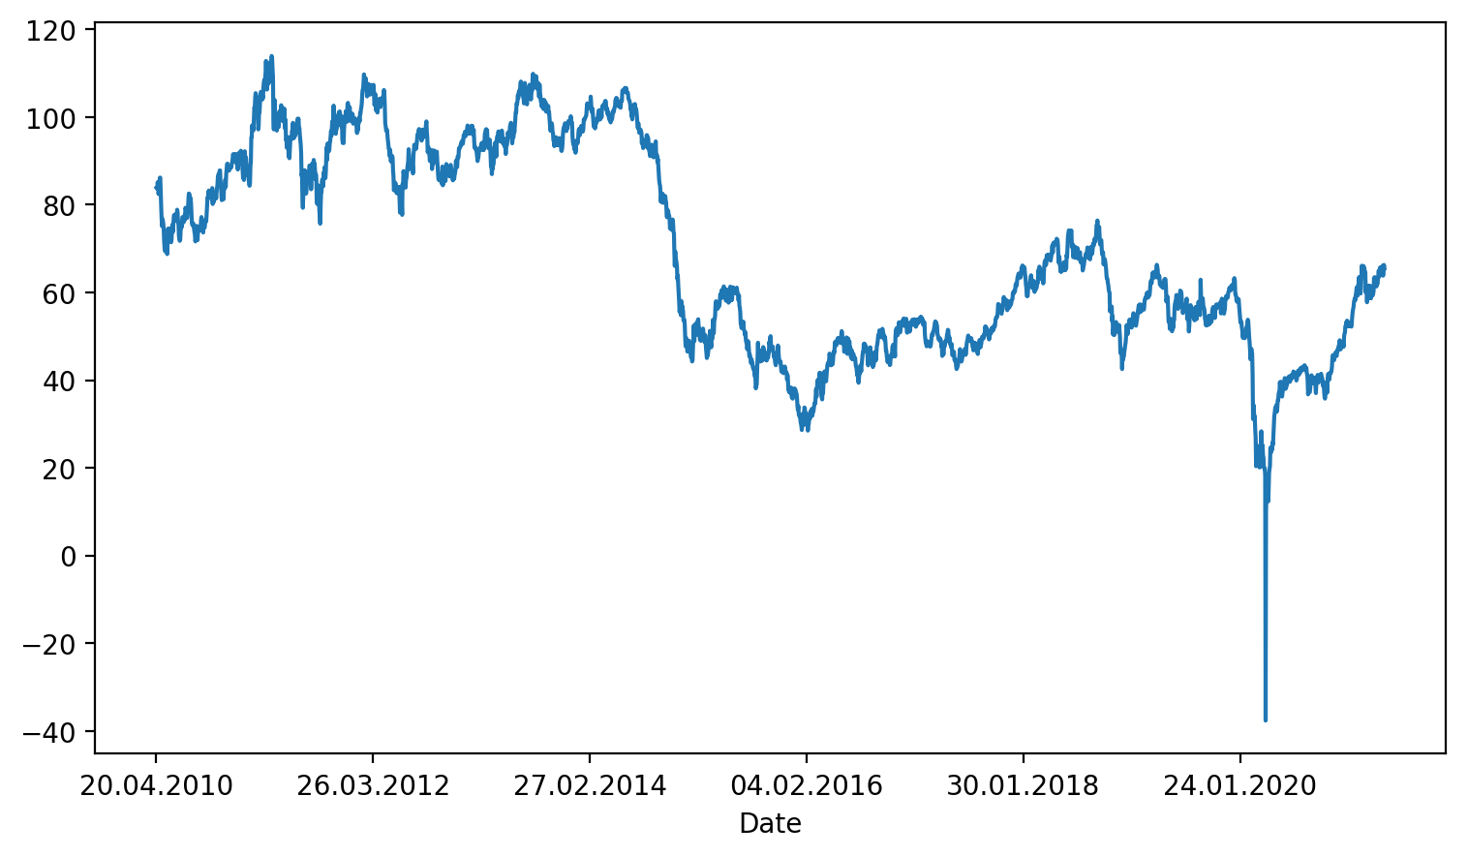

In our opinion, the best way to measure is to use IPI (Industrial Production Index) and CPI (Consumer Price Index ). Those indexes allow us to see changes in production of goods and consumption of them as well.

**Table 6. Summary table 5.**

|  |  |
| --- | --- |
| **Summary** | **Information** |
|  | Covid-19 caused supply chains breakdown which caused raw materials price decrease |
|  | Best measure of impact of pandemic on the economy is IPI and CPI |

## **Box-Jenkins method – ARIMA modeling**

Box-Jenkins analysis refers to a systematic method for identifying, fitting, verifying, and using integrated autoregressive moving average time series (ARIMA) models. According to NCSS, the method is suitable for time series of medium and long length, at least 50 observations.

In our study, we will use an integrated autoregression model – the ARIMA moving average-to predict the future values of the series.

If our series is stationary, we can start exploring different ways to get a suitable model for the data. The ARIMA (p, d, q) model is a differentiated series of the ARMA(p, q) model in which the difference ' d ' corresponds to $X_{t}$. Model has the general form:

$$∆^{d}X_{t}=c+ \sum_{i=1}^{p}{a_{i}∆^{d}X_{t-i} }+ \sum_{j=1}^{q}{b_{j}z_{t-j} }+z_{t}$$

where is $z_{t}-$ the stationary time series;

$a_{i}$, $b_{j}$, $c$- model parameters.

- time series difference operator of order d (sequential taking of d times of first-order differences-first from the time series, then from the obtained first-order differences, then from the second-order differences, etc.)

General idea of Box-Jenkins method can be implemented as:

$$X_{t}→AR filter(long term)→Integration filter(stochastic trend)→MA filter(short term) and white noise error$$

## **Problems of ARIMA**

The autoregressive integrated moving average or ARIMA is a forecasting method for one-dimensional time series data.

As the name suggests, it supports autoregression and moving average elements. The integrated element refers to the difference that allows the method to maintain time series data using a trend.

The problem with ARIMA is that it does not support seasonal data. This is a time series with a repeating cycle.

ARIMA expects that the data is not seasonal, or the seasonal component will be removed, for example, seasonally adjusted using methods such as seasonal variance.

## **Moving to SARIMA**

SARIMAX – is the newest interpretation of Box-Jenkins method – ARIMA models.

The Seasonal Autoregressive Integrated Moving Average, SARIMA or Seasonal ARIMA, is an extension of ARIMA that explicitly supports one-dimensional time series data with a seasonal component.

This method allows you not to separate the data by seasonality, trends, and stationarity. It can forecast with seasonality and trend in mind, adding an additional four parameters.

It adds three new hyperparameters to denote autoregression (AR), difference (I), and moving average (MA) for the seasonal component of the series, and an additional parameter for the seasonality period.

The ARIMA seasonal model is formed by including additional seasonal terms in ARIMA. The seasonal part of the model consists of terms that are very similar to the non-seasonal components of the model but include the reverse shifts of the seasonal period.

## **Methods of defining models: Dickey-Fuller test and Akaike information criterion.**

Dickie-Fuller Test (DF-test-Dickie-Fuller Test, ADF) - this is a technique that is used in applied statistics and econometrics to analyze time series to check for stationarity.

AIC is a method of selecting a model from a set of models to measure the degree of compliance of the estimated statistical model. It is based on information theory and is a criterion that searches for a model that matches the truth well but has few parameters. (Ping P., etc. (2013)).

## **The quality of predictions**

By MAPE and visualization we can discover the quality of SARIMAX predictions.

The average absolute percentage error (MAPE), also known as the average absolute percentage deviation (MAPD), is a measure of the prediction accuracy of a forecasting method in statistics, such as trend estimation, also used as a loss function for regression problems in machine learning. It usually expresses precision.

## **Applying of forecasting algorithms**

Most of the previous researches are connected to forecasting crude oil, gold market price by Box-Jenkins algorithm and ARCH-family, not comparing them.

For example, on the metal market Hammoudeh, S. And Yuan, Y. (2008) used three "two-factor" volatility models from the GARCH family to study the volatility behavior of three strategic commodities: gold, silver, and copper in the face of crude oil and interest rate shocks. They find out, that the past oil shock does not have a similar effect on all three metals. Monetary policy and, to a lesser extent, oil Shocks have a calming effect on precious metals, but not on copper if the Treasury Bills rate is used. Crises increase the volatility of the metal. It will be interesting to compare our results with them.

Another example of applying Box-Jenkins method is Mensah, K. (2015) title. They examined the dynamics of the monthly Brent oil price for the last two decades using the Box Jenkins ARIMA techniques, then they shown that such model is not able to capture the volatility inherent in the crude oil price for an accurate forecast. They discovered that ARIMA(1,1,1) is the best forecasting model for brent crude oil but still not good enough to forecast.

Third title, that are related to our work is title written by Ping P., etc. (2013). They compared two models: GARCH model and Box-Jenkins method. Models were compared in case of forecasting gold prices in Malaysia. By using Akaike's information criterion (AIC) as the goodness of fit measure and mean absolute percentage error (MAPE) as the forecasting performance measure, their study conducts that GARCH(1,1) is a more appropriate model for Gold forecasting in Malaysia than Box-Jenkins ARIMA(1,1,1). They used E-views, we are going to us MatLab. It will be interesting to compare our results.

Shiferaw, Y. (2012) inside their work find out it too, that GARCH models is more suitable for forecasting, than ARIMA. But they did it on agriculture industry of Ethiopia. In our case it’s just another interesting example of comparing those both methods.

We think that our work are important in case of preliminary research, especially Ping P., etc. (2013), our work is related to define good forecasting instrument for different types (clusters) of raw materials, which are going to be clustered according to their pandemic reaction (decreased type, stable type, increased type), and which variables are good inside the best model. We want to look at how these predictive mechanisms respond to such severe economic shocks that were caused by the pandemic. We believe that our work will expand the experience of the previous ones.

Yaziz, R. etc. (2017), showed in their work that the model of Box-Jenkins - GARCH a promising tool for forecasting higher volatile time series. Their study proposed a framework for determining the optimal sample size using the Box-Jenkins model with GARCH for practical application in analyzing and predicting more volatile data. The proposed structure was used for the daily series of world gold prices from 1971 to 2013. The data was divided into 12 different sample sizes (from 30 to 10,200). Each sample was tested using a different combination of the Box-Jenkins - GARCH hybrid model. Their study showed that the optimal sample size for predicting the price of gold in the hybrid model is 1250 data from a 5-year sample.

The main purpose of the work of Kirkulak-Uludag, B. and Safarzadeh, O. (2021) was to study the volatility between oil prices and Chinese stock indices of industrial raw materials, including oil, coal, iron and non-ferrous metals. To achieve this goal, OPEC and WTI oil prices were used as oil benchmarks, and several GARCH multidimensional models were applied for daily closing prices of stock indices for the period from 2004 to 2014. Among the models, the VAR-GARCH model is best suited for data. The results showed significant volatility between the oil yield and the yield of Chinese commodity stocks.

Another example of applying Box-Jenkins models in the work of Guha, B and Bandyopadhyay, G. (2016) [journal of management science]. Their study were based on secondary monthly data for Gold price which was collected from Multi Commodity Exchange of India Ltd (MCX) ranging from November 2003 to January 2014. They did several ARIMA models and calculate MAE and MAPE inside the model construction. The best ARIMA model that they have defined according to lowest BIC is ARIMA(1,1,1) with MAPE – 3.245 and MAE – 477.330.

Next example is Mombeini, H., & Yazdani-Chamzini, A. (2015), they constructed ARIMA(1,1,0) and compared it ANN (Artificial Neural Network). They took monthly data for gold, April 1998 to July 2008. Silver, oil, USD index and others were taken for ANN training. They concluded that ARIMA are much worser than Artificial Neural Network in case of forecasting gold prices.

**Table 7. Summart table 6.**

|  |  |
| --- | --- |
| **Summary** | **Information** |
|  | Previous research’s about applying of Box-Jenkin’s method were mostly concentrated on gold and oil prices |
|  | Other forecasting methods (like GARCH, ANN) were better for price forecasting even standard ARIMA models, ARIMA models showed worst prediction accuracy. |
|  | They weren’t tested in pandemic situation.  Mixed models are more accurate than clear ones. |

After all the literature we have read we can conduct several hypotheses:

1. The quality of forecast depends on assets volatility.
2. ARIMA models works better on non-volatile assets.
3. Ferrous and Non-Ferrous metals are going to drop their market price in the nearest future. According to the horizon,
4. Box-Jenkins on non-seasonal data will allow us to create better forecasts than SARIMAX on seasonal data .

# **Part 2. Data and Methodology**

In previous studies that are related to applying Box-Jenkin’s method into a commodity price prediction research design were about quantitative method with data collection type – secondary.

Quantitative research is a research strategy that focuses on quantifying data collection and analysis. It is formed on the basis of a deductive approach, where the emphasis is on testing the theory formed by empirical and positivist philosophies.

Secondary Data is the data that are collected by someone else for a purpose other than the researcher’s current project and has already undergone the statistical analysis is called as.

For example, Yaziz, R. etc. (2017), showed in their work that the model of Box-Jenkins - GARCH a promising tool for forecasting higher volatile time series. Their study proposed a framework for determining the optimal sample size using the Box-Jenkins model with GARCH for practical application in analyzing and predicting more volatile data. They methodology was connected with quantitative method research, and they took data about the daily series of world gold prices from 1971 to 2013. In this study, a 41-year daily world gold prices comprising of a total of 10 200 price data were used starting from 2nd January 1973 to 17th December 2013 of 5-day-per-week frequencies. Values are quoted in US dollars per ounce and the source data were obtained from [www.kitco.com](http://www.kitco.com). #In our work we will use kitco for Nickel price collection.

Another example is Shiferaw, Y.(2012) about agriculture industry of Ethiopia. They But they did it on agriculture industry of Ethiopia. For the data collection they preferred secondary data collection method – they took data from central statistical agency. Data sample: commodity prices of cereal crops, pulse crops and oil seeds with the sample covers from May 2001 to April 2011 G.C. and has a total of 120 observations.

Third example about applying Box-Jenkins method is Mensah, K. (2015) title. They examined the dynamics of the monthly Brent oil price for the last two decades using the Box Jenkins ARIMA techniques, then they shown that such model is not able to capture the volatility inherent in the crude oil price for an accurate forecast. They collected data about Brent crude oil prices from Energy Information Administration (EIA) - International Energy Statistics.

## **Data collection**

Due to meet the objectives of current research we suggest using secondary data. Several reasons could be named, why it is an appropriate method for this study. First, in order to conduct a proposed research a big amount of data is required. we want to construct several forecasts by SARIMAX model in Box-Jenkins method to see how forecasts changes according to super-crisis that came by corona-virus, plus this allows model to group raw materials to construct them individually. Secondly, by using secondary the researcher may easily transform it for quantitative research (which it would be) in software like Excel. I took daily data, from middle of December 2010 to middle May of 2021. By Excel I transformed data to UTF-8 format and took by “text” function only end week data (Friday’s). To sum up, secondary data collection is a good way to test the hypothesis based on synthesis of information from existing literature by using large amount of data gathered from different international sources. We are going to use quantitative methods – Box-Jenkins forecasting model construction – SARIMAX or just ARIMA, if there is no seasonality according to tests. Data obtained from resources – finanz.com – about gold, silver, oil. Total observations are mentioned in summary table below.

**Table 8. Summary table of observations.**

|  |  |  |  |  |  |
| --- | --- | --- | --- | --- | --- |
| **Drag-Metals** | **Before Covid** | **With Covid** | | **Size of forecast (in weeks)** | |
| **Number of observations** | **Number of observations** | | **Before covid** | **With Covid** |
| Gold | 467 | 532 | | 71 | 81 |
| Silver | 468 | 531 | | 71 | 81 |
| Platinum | 467 | 529 | | 71 | 81 |
| Palladium | 467 | | 529 | 71 | 81 |
| **Non-Metals** |  | | |  |  |
| Aluminum | 464 | | 525 | 70 | 80 |
| Cuprum | 463 | | 524 | 69 | 80 |
| Nickel | 420 | | 481 | 64 | 73 |
| Plumblum | 420 | | 481 | 64 | 73 |
| Zinc | 419 | | 480 | 64 | 73 |
| Stannum | 419 | | 480 | 64 | 73 |
| **Metals** |  | | |  |  |
| Iron-Ore* | 460 | | 515 | 70 | 78 |
| **Energy carriers** |  | | |  |  |
| Brent Oil | 470 | | 532 | 72 | 81 |
| Coal | 434 | | 489 | 66 | 74 |
| WTI Oil | 469 | | 531 | 70 | 81 |
| Uranium | 447 | | 475 | 68 | 72 |
| Gas (Henry Hub) | 469 | | 531 | 71 | 81 |

## **Beginning of crisis**

As the beginning of pandemic situation and crisis starts we defined the end of January 2020, it is the time when Chinese government starts to close borders and that although caused breaking of supply chains. (ria.ru, vc.ru)

## **Train-test splitting**

We split our dataset in proportion of 15% to test data and 85% of training data. Realization in table 9.

**Table 9. realization of train/test splitting.**

|  |
| --- |
| train = df[:int(0.85*(len(df)))]  test = df[int(0.85*(len(df)))-1:]  df – our dataset |

## **Stationarity or Seasonality**

Time series data, such as commodity prices, may exhibit non-stationarity at their levels. To evaluate its model, it becomes necessary to detrend the data before a certain statistical inference can be made. We can say that a stationary series is a flat series with no trend, constant variance in time, constant autocorrelation in time, and no periodic fluctuations.

Dickie-Fuller Test (DF-test-Dickie-Fuller Test, ADF) - this is a technique that is used in applied statistics and econometrics to analyze time series to check for stationarity.

We used Augmented Dickey-Fully test to see is data are stationarity or not. If it stationary than the p-value of tests result is lower than 0.05 and we could apply just ARIMA model. If it’s not stationary, than we should apply SARIMAX.

In Python ADF test realized in statsmodels.tsa.stattools package. Realization in table 10 and results in table 11. According to them most of the data seasonal, except Silver and Plumbum in both periods.

**Table 10. Realization of ADF test**

|  |
| --- |
| dftest = adfuller(df[' Price' ]) - Test.  dfoutput = pd.Series(dftest[0:4],index=[' Test Statistic' ,' p-value' ,'#Lags Used',' Number of Observations Used' ])-Our output  df – our dataset. |

**Table 11. Summary results**

|  |  |  |  |
| --- | --- | --- | --- |
| **Drag-Metals** | **Before Covid** | **With Covid** | |
| **P-value** | **P-value** | |
| Gold | 0.49 | 0.67 | |
| Silver | 0.025 | 0.036 | |
| Platinum | 0.41 | 0.37 | |
| Palladium | 1 | | 0.999 |
| **Non-Metals** |  | | |
| Aluminum | 0.22 | | 0.35 |
| Cuprum | 0.22 | | 0.68 |
| Nickel | 0.073 | | 0.056 |
| Plumbum | 0.006 | | 0.005 |
| Zinc | 0.316 | | 0.346 |
| Stannum | 0.092 | | 0.186 |
| **Metals** |  | | |
| Iron-Ore* | 0.137 | | 0.74 |
| **Energy carriers** |  | | |
| Brent Oil | 0.737 | | 0.364 |
| Coal | 0.197 | | 0.344 |
| WTI Oil | 0.137 | | 0.741 |
| Uranium | 0.0028 | | 0.0017 |
| Gas (Henry Hub) | 0.096 | | 0.039 |

## **Box-Jenkins realization**

In our study, we will use the ARIMA integrated autoregression – moving average model to predict the future values of the series. In model we have to define 3 parameters:

P: The order of trend autoregression.

D: The order in which the trend changes.

Q: The trend of the moving average.

According to SARIMAX definition - it’s ARIMA with seasonality already included. That means that we didn’t need to decompose data on trend, seasonality and residuals. All included we just need to specify extra parameters:

p: Seasonal order of autoregression.

d: The order of the seasonal difference.

q: The seasonal order of the moving averages.

m: The number of time steps per seasonal period.

m is equal to 52 according to our data, we took weekly data. (m=1 for yearly, m = 12 for monthly and m = 365 for daily but there is such powerful pc to realize it, and people put 7, but accuracy of the forecast goes down because of it)

## **Methods of comparing models.**

In our research we used two ways of comparing models after checking the adequacy of the model – AIC and MAPE. Like Ping P., etc. (2013). They compared two models: GARCH model and Box-Jenkins method. Models were compared in case of forecasting gold prices in Malaysia. By using Akaike's information criterion (AIC) as the goodness of fit measure and mean absolute percentage error (MAPE) as the forecasting performance measure. They used E-views, we are going to us Python. In our research we will use AIC to compare SARIMAX and ARIMA models to choose best parameters for them.

AIC is a method of selecting a model from a set of models to measure the degree of compliance of the estimated statistical model. It is based on information theory and is a criterion that searches for a model that matches the truth well but has few parameters. (Ping P., etc. (2013))

$$AIC= \frac{2kn}{n-k-1}-2ln⁡(L)$$

General formula of Akaike information criterion

By the MAPE we checked the accuracy of predictions that were made by our autoregressions models.

The average absolute percentage error (MAPE), also known as the average absolute percentage deviation (MAPD), is a measure of the prediction accuracy of a forecasting method in statistics, such as trend estimation, also used as a loss function for regression problems in machine learning. It usually expresses precision, it calculates according to formula 1.

$$M= \frac{1}{n}\sum_{t=1}^{n}{| \frac{A_{t}-F_{t}}{A_{t}}|}$$

To find out how our forecast switches we decided to use the Mann-Whitney U-test to check for the discrepancy between our predictions to the covid and together with it.

# **Practice realization**

For defining best parameters for SARIMAX and ARIMA models first of we can look at ACF and PACF graphics. Or the easiest way to that we construct lots of models by one command and according to lowest AIC test chose best parameters. Summary results you can see in table 9.

To find out best parameters P, D, Q, p, d, q we have used “autoarima” function from “pmdarima” package. And for SARIMAX and ARIMA construction we have used “statsmodels.tsa.statespace.sarimax” package. Example of code on table 12.

**Table 12. Example of code.**

|  |
| --- |
| #import pmdarima as pm  model = pm.auto_arima(train['Price'], d=1, D=1,  m=52, trend='c',  seasonal=True,  start_p=0, start_q=0, max_order=9, test='adf',  stepwise=True, trace=True) |
| from statsmodels.tsa.statespace.sarimax import SARIMAX  model = SARIMAX(train['Price'],  order=(0,1,0),seasonal_order=(2,1,0,52))  results = model.fit()  results.summary() |

To define if predictions are not same, that our forecast have been switched we have runed “scipy” package on same length prediction datasets, that are starts from same indexes. Example of code are in table 14.

**Table 14. Example of code.**

|  |
| --- |
| import scipy  scipy.stats.mannwhitneyu(predict1,predictions,use_continuity=True, alternative=None) |

**Table 15. Summary table.**

|  |  |  |  |  |  |  |  |  |  |  |
| --- | --- | --- | --- | --- | --- | --- | --- | --- | --- | --- |
| **Drag-Metals** | **Arima** | | | **S** | | | | **Mann-Whitney test.** | **AIC** | **MAPE** |
| **P** | **D** | **Q** | **p** | **d** | | **q** |  |
| Gold Before | 0 | 1 | 0 | 2 | 1 | | 0 | 2,2 $e^{-28}$ | 3451.087 | 14.495% |
| Gold With | 0 | 1 | 0 | 2 | 1 | | 0 | 3982.217 | 10,845% |
| Silver Before | 5 | 1 | 2 | 0 | 0 | | 0 | 2.2 $e^{-28}$ | 1239.745 | 9.7% |
| Silver With | 5 | 1 | 2 | 0 | 0 | | 0 | 1358.845 | 18.48% |
| Platinum Before | 1 | 1 | 0 | 1 | 1 | | 1 | 2.2 $e^{-28}$ | 3538.003 | 20.88% |
| Platinum With | 1 | 1 | 0 | 2 | 1 | | 0 | 4056.76 | 12.39% |
| Palladium Before | 0 | 1 | 0 | 2 | 1 | | 1 | 2,2 $e^{-28}$ | 3368.316 | 30.23% |
| Palladium With | 0 | 1 | 0 | 1 | 1 | | 1 | 3967.29 | 12,9% |
| **Non-Metals** |  | | | | | | |  | | |
| Aluminum Before | 0 | 1 | 0 | 2 | 1 | | 0 | 4,69 $e^{-28}$ | 3813.902 | 23,05% |
| Aluminum With | 0 | 1 | 0 | 2 | 1 | | 0 | 4365.873 | 10,17% |
| Cuprum Before | 1 | 1 | 0 | 2 | 1 | | 1 | 4,69 $e^{-28}$ | 4706.253 | 8.59% |
| Cuprum With | 1 | 1 | 0 | 2 | 1 | | 1 | 5382.534 | 14.04% |
| Nickel Before | 1 | 1 | 1 | 2 | 1 | | 1 | 4.39 $e^{-26}$ | 4889.209 | 17,76 |
| Nickel Woth | 0 | 1 | 0 | 2 | 1 | | 1 | 5695.404 | 18,29% |
| Plumblum Before | 1 | 1 | 1 | 0 | 0 | | 0 | 9,40 $e^{-23}$ | 4138.548 | 4.18% |
| Plumblum With | 1 | 1 | 1 | 0 | 0 | | 0 | 4704.033 | 12.49% |
| Zinc Before | 0 | 1 | 0 | 2 | 1 | | 1 | 6.25 $e^{-24}$ | 3639.059 | 11.47% |
| Zinc With | 0 | 1 | 0 | 2 | 1 | | 1 | 4244.951 | 12.72% |
| Stannum Before | 0 | 1 | 0 | 0 | 1 | | 1 | 9,37 $e^{-26}$ | 4949.885 | 10.3% |
| Stannum With | 0 | 1 | 0 | 2 | 1 | | 0 | 5750.671 | 18,89% |
| **Metals** |  | | | | | | |  | | |
| Iron-Ore* Before | 1 | 1 | 0 | 2 | | 1 | 1 | 9.99 $e^{-28}$ | 1970.201 | 26.43% |
| Iron-Ore* With | 1 | 1 | 1 | 2 | | 1 | 0 | 2247.528 | 19.19% |
| **Energy carriers** |  | | | | | | |  | | |
| Brent Oil Before | 0 | 1 | 0 | 2 | | 1 | 0 | 2.2 $e^{-28}$ | 1844.779 | 36.6% |
| Brent Oil With | 0 | 1 | 0 | 2 | | 1 | 0 | 2113.572 | 38% |
| Coal Before | 3 | 1 | 0 | 2 | | 1 | 1 | 2.06 $e^{-26}$ | 1337.730 | 40.25% |
| Coal With | 3 | 1 | 0 | 2 | | 1 | 1 | 1516.969 | 16.55% |
| WTI Oil Before | 0 | 1 | 0 | 2 | | 1 | 0 | 2.2 $e^{-28}$ | 1818.849 | 41.35% |
| WTI Oil With | 1 | 1 | 0 | 2 | | 1 | 0 | 2080.030 | 36.7% |
| Uranium Before | 1 | 0 | 1 | 0 | | 0 | 0 | 9.37 $e^{-26}$ | 1706.478 | 6.71% |
| Uranium With | 1 | 0 | 1 | 0 | | 0 | 0 | 1794.270 | 7.86% |
| Gas (Henry Hub) Before | 0 | 1 | 0 | 1 | | 1 | 0 | 3.71 $e^{-32}$ | -19.093 | 19.19% |
| Gas (Henry Hub) With | 1 | 1 | 1 | 0 | | 0 | 0 | -223.804 | 19.06% |

# **Discussion**

In all cases we have discovered that Mann-Whitney test are lower than 0.05, which means that ARIMA and SARIMAX are sensitive to price change, secondly it proves our hypothesis about prediction shifts because of crisis such as COVID-19.

In other hand we had in most cases MAPE lower 20%, except WTI, Palladium before COVID, Platinum before COVID and Aluminum before COVID.

In all cases, except where were applied ARIMA determination coefficient were negative, which means that models are so suitable for high volatile data such as raw materials.

AIC depends on number of data size, so it could be applied only in defining best models inside ARIMA or SARIMA, that is why they just important inside models for defining the best ones.

Comparing to Mensah K.(2015) results, they got MAE from 0.042 to 0.054 on forecast horizon (from 1 year to 3 years), our forecast occurred in both cases little bit higher than one year and it were 72 and 81 weeks. They applied ARIMA model with (1,1,1), our models take seasonal ARIMA with (0,1,0) (2,1,0) [52] in both cases according to ADF tests – it was seasonal and by choosing lowest AIC. Our MAE were in SARIMAX forecast 22.99 and 14.26 which means that oil prices from 2012 began much more volatile and ARIMAs starts to catch fluctuations of the prices much worse. That is why application of ARIMAs models for them began with worst accuracy on it. It can be mentioned by the graphics results from Mensah and ours (table 16,17).

**Table 16. Mensah K(2015) results plot forecast with actual value**

|  |
| --- |
|  |

**Table 11. Our results on Brent oil**

|  |
| --- |
|  |

Comparing to Ping results, they got MAPE from 0.81 for ARIMA models, and 0.809 for GARCH mode;, our forecast occurred in both cases little bit higher than one year and it were 72 and 81 weeks. They applied ARIMA model with (1,1,1), our models take seasonal ARIMA with (0,1,0) (2,1,0) [52] in both cases according to ADF tests – it was seasonal and by choosing lowest AIC. Our MAPE were in SARIMAX forecast 36.6% and 38% which means that oil prices from 2012 began more volatile and ARIMAs starts to catch fluctuations of the prices much worse. That is why application of ARIMAs models for them began with worst accuracy on it. On the other hand they calculate MAPE inside ARIMA model, inside SARIMAX we got 0.025 and 0.025, which is much lower. What means inside studying SARIMAX is much more flexible than ARIMA and GARCH.

In Yaziz work they create ARIMA-GARCH mixed models. They forecast gold from 1971 to 2013. They got MAE from 0.0086 to 0.0099. In our case we got by SARIMA 14.495% before COVID and 10.845% after covid MAPE, which means that such volatile data as gold, according to augmented Dickey-Fuller tests p-value were 0.49 and 0.68 requires more flexible ways forecasting such as ARIMA-GARCH mixes or others.

In Mehdi K. work they got 40 days gold dataset from 2005 to 2006 year and forecast on it. They got MAPE equal to 10.5% which in ARIMA model, that is lower than ours. What means that first of all, gold became more volatile since those days, more over for ARIMAs models is hard to get different trends. According to their graphs of gold prices they forecast it on data without big fluctuations, which leads it lower MAPE.

Assylbekov Z. (2018), forecasts uranium prices by ARIMA models, he did for nearest months days on monthly data from 2000 to 2017. He chooses ARIMA (2,1,0) as best model according to AIC. He did not calculate MAPE, but in his paper he prooved us with the results of his forecast with actual data that is why according to MAPE formula it is easy to calculate. It was 5.33%. and it is really close our results – 6.71% and 7.81%. Difference can be explained by the range of predicted data - he got 5 months (5 prediction) in more or less stable periods, we have more than one year in both cases (68 and 71 prediction).

ARIMA models in our cases looks like a line because (mentioned in appendix), there is no seasonality and there is no strong trend.

Although we can mention by MAPE that lowest of it were in models that do not have seasonality in most cases. That means that forecasting by ARIMA models is more appreciate in stable data without seasonality rather than more fluctuate as most of raw materials.

Brief summary of comparison of our results with most related researches are presented in summary table below.

**Table 18. summary table of content.**

|  |  |  |  |
| --- | --- | --- | --- |
| **Author** | **MAE** | **MAPE** | **Summary** |
| **Mensah K.(2015)** | **0,042 - 0,054** |  | Our 22.99 and 14.26. Oil prices from 2012 began much more volatile and ARIMAs starts to catch fluctuations of the prices much worse. |
| **Ping P. (2013)** |  | **0,81% (inside the model)** | On their data they got strong upper trend. We got 14.495% before COVID and 10.845% after. Gold became more volatile since those days, more over for ARIMAs models is hard to get different trends. |
| **Yaziz R. (2017)** | **0,0086 - 0,0099** |  | They create ARIMA-GARCH mixed model, MAE was from 0,0086 to 0,0099 (they forecast it for 3 time periods from one year to three year) |
| **Medhi K. (2008)** |  | **10.5%** | We got 14.495% before COVID and 10.845% after. Gold became more volatile since those days, more over for ARIMAs models is hard to get different trends. |
| **Assylbekov Z. (2018)** | **5.33%** | Our results – 6.71% and 7.81%. Difference can be explained by the range of predicted data - he got 5 months (5 prediction) in more or less stable periods, we have more than one year in both cases (68 and 71 prediction). |

**Conclusion**.

In this study, the performance of different methods for forecasting the raw materials changes was investigated. The forecasting methods evaluated include the ARIMA and SARIMAX models. The raw materials price data from the end of December 2010 to the middle of May 2021 were used to develop various models investigated in this study. We constructed ARIMA and SARIMAX models for two time periods – before COVID-19 and with it. Three performance evaluation measures, including MAE, MAPE and AIC, are adopted to analyze the performances of various models developed. Mann-Whitney test were conducted too. The results show that the Box-Jenkins method is the most adapted and is suitable for a less volatile date than raw material prices. So that is why our recommendation for the management of the commodities producers to look careful at the forecasting method you choose. This method can be applicable for commodities such as uranium, where price do not change dramatically. Summary of the results is presented in table 18 and 19.

**Table 18. Research questions answers summary.**

|  |  |  |
| --- | --- | --- |
| **№** | **RQ** | **Answer:** |
| **1** | **Is it possible to apply ARIMA models in conditions of high uncertainty?** | **No. As results of MAPE in predictions of high volatile data showed, in most cases it is higher than 20%** |
| **2** | **Does Box-Jenkins method good for creating forecasts on volatile data?** | **In some cases, it good (for example Uranium), in other managers should choose other methods of forecasting** |
| **3** | **Can it be applied for commodity prices prediction?** | **Depends on type of raw material, how it volatile.** |

**Table 19. Hypothesis summary.**

|  |  |  |
| --- | --- | --- |
| **№** | **Hypothesis** | **Answer** |
| **1** | **The quality of forecast depends on assets volatility** | **Concluded** |
| **2** | **ARIMA models works better on non-volatile assets** | **Concluded** |
| **3** | **Box-Jenkins on non-seasonal data will allow us to create better forecasts than SARIMAX on seasonal data .** | **Partially concluded. Depends on type of raw material.** |
| **4** | **Because of the crisis situation the forecast that are created by the model will be switched** | **According to Mann-Whitney test – Concluded** |

**References**

1. Lola, S., & Albina, G. (2009). The world crisis and the raw-material oriented transition economies. Central Asia and the Caucasus, (4-5 (5859)).
2. Matveenko, V. (2012). Technology choice and economic growth in a resource-dependent economy. Economic science of modern Russia, (1 (56)).
3. Leybovich, I. (2012). How to Cope with Unpredictable Raw Materials Costs.
4. Mensah, E. K. (2015). Box-Jenkins modelling and forecasting of Brent crude oil price.
5. https://www.ncss.com/wp-content/themes/ncss/pdf/Procedures/NCSS/The_Box-Jenkins_Method.pdf
6. Energy Information Administration (EIA), ‘International Energy Statistics’
7. Hieronymi, K. (2012). Hewlett-Packard's WEEE management strategy. In Waste Electrical and Electronic Equipment (WEEE) Handbook (pp. 613-637). Woodhead Publishing.
8. https://www.cmegroup.com/ - Chicago Mercantile Exchange
9. https://spimex.com/ - Saint Petersburg international commodity exchange
10. United Nations UNCTAD Covid-19 Report - https://unstats.un.org/unsd/ccsa/documents/covid19-report-ccsa.pdf
11. Moheb-Alizadeh, H., & Handfield, R. (2018). The Impact of Raw Materials Price Volatility on Cost of Goods Sold (COGS) for Product Manufacturing. IEEE Transactions on Engineering Management, 65(3), 460-473.
12. C. W. Yang, M. J. Hwang, and B. N. Huang, “An analysis of factors 811 affecting price volatility of the US oil market,” Energy Econ., vol. 24, 812 pp. 107–119, 2002.
13. X. Zhang, K. K. Lai, and S.-Y. Wang, “A new approach for crude oil price 808 analysis based on empirical mode decomposition,” Energy Econ., vol. 30, 809 no. 3, pp. 905–918, 2008.
14. Narayan, P. K., & Narayan, S. (2007). Modelling oil price volatility. Energy policy, 35(12), 6549-6553.
15. Hammoudeh, S., & Yuan, Y. (2008). Metal volatility in presence of oil and interest rate shocks. Energy Economics, 30(2), 606-620.
16. Bagchi, D. (Ed.). (2019). Nutraceutical and functional food regulations in the United States and around the world. Elsevier.
17. Reis, R. L. (2019). Encyclopedia of tissue engineering and regenerative medicine. Academic Press.
18. Chen, H., Liao, H., Tang, B. J., & Wei, Y. M. (2016). Impacts of OPEC's political risk on the international crude oil prices: An empirical analysis based on the SVAR models. Energy Economics, 57, 42-49.
19. Hamilton, J. D. (2009a). Understanding crude oil prices. The Energy Journal, 30(2).
20. Kilian, L. (2009). Not all oil price shocks are alike: Disentangling demand and supply shocks in the crude oil market. American Economic Review, 99(3), 1053-69.
21. Hamilton, J. D. (2009b). Causes and Consequences of the Oil Shock of 2007-08 (No. w15002). National Bureau of Economic Research.
22. Mu, X., & Ye, H. (2011). Understanding the crude oil price: how important is the China factor?. *The Energy Journal*, *32*(4).
23. Kilian, L., & Murphy, D. P. (2014). The role of inventories and speculative trading in the global market for crude oil. Journal of Applied econometrics, 29(3), 454-478.
24. Buyuksahin, B., & Harris, J. H. (2011). Do speculators drive crude oil futures prices?. The Energy Journal, 32(2).
25. Cifarelli, G., & Paladino, G. (2010). Oil price dynamics and speculation: A multivariate financial approach. Energy Economics, 32(2), 363-372.
26. Liu, L., Wang, Y., Wu, C., & Wu, W. (2016). Disentangling the determinants of real oil prices. Energy Economics, 56, 363-373.
27. Liu, Y., Yang, C., Huang, K., & Gui, W. (2020). Non-ferrous metals price forecasting based on variational mode decomposition and LSTM network. Knowledge-Based Systems, 188, 105006.
28. Adams, F. G., & Vial, J. (1988). Explaining recent metals price swings: Exchange rates and structural considerations. Resources Policy, 14(2), 85-96.
29. Worrell, E., Price, L., Martin, N., Farla, J., & Schaeffer, R. (1997). Energy intensity in the iron and steel industry: a comparison of physical and economic indicators. Energy policy, 25(7-9), 727-744.
30. McCown, J. R., & Zimmerman, J. R. (2006). Is gold a zero-beta asset? Analysis of the investment potential of precious metals. *Analysis of the Investment Potential of Precious Metals (July 24, 2006)*.
31. Batten, J. A., Ciner, C., & Lucey, B. M. (2010). The macroeconomic determinants of volatility in precious metals markets. *Resources Policy*, *35*(2), 65-71.
32. Erb, C. B., & Harvey, C. R. (2006). The strategic and tactical value of commodity futures. Financial Analysts Journal, 62(2), 69-97..
33. Akbulaev, N., Mammadov, I., & Aliyev, V. (2020). Economic impact of COVID-19. *Sylwan*, *164*(5).
34. McKibbin, W., & Fernando, R. (2020). The economic impact of COVID-19. *Economics in the Time of COVID-19*, *45*.
35. Lan, J., Wang, K., Fa, G., Hao, F., Hua, B., Fu, L., ... & Cui, B. (2019). Global Pattern of International Uranium Trade and its Impact on Ecological Environment and its Various Aspects. *Ekoloji*, *28*(107), 3351-3364.
36. Ferguson, A., & Lam, P. (2016). Government policy uncertainty and stock prices: The case of Australia's uranium industry. *Energy Economics*, *60*, 97-111.
37. Varfolomeeva, E. D. (2009). Analytical module for forecasting the profitability of financial instruments based on the GARCH-model of volatility Thesis. St. Petersburg: St. Petersburg State University.
38. Ping, P. Y., Miswan, N. H., & Ahmad, M. H. (2013). Forecasting Malaysian gold using GARCH model. *Applied Mathematical Sciences*, *7*(58), 2879-2884.
39. Yaziz, S. R., Zakaria, R., & Ahmad, M. H. (2017, September). Determination of sample size for higher volatile data using new framework of Box-Jenkins model with GARCH: A case study on gold price. In Journal of Physics: Conference Series (Vol. 890, No. 1, p. 012161). IOP Publishing.
40. Kirkulak-Uludag, B., & Safarzadeh, O. (2021). Exploring shock and volatility transmission between oil and Chinese industrial raw materials. Resources Policy, 70, 101974.
41. Shiferaw, Y. (2012). Modeling price volatility for some selected agricultural products in Ethiopia: ARIMA-GARCH applications. Available at SSRN 2125712.
42. Monge, M., & Gil-Alana, L. A. (2021). Lithium industry and the US crude oil prices. A fractional cointegration VAR and a Continuous Wavelet Transform analysis. *Resources Policy*, *72*, 102040.
43. <https://www.scss.tcd.ie/khurshid.ahmad/Research/Fuzzy_Logic/2007_Khashei%20et%20al_NeuroFuzzyARIMA.pdf>
44. nur.nu.edu.kz/bitstream/handle/123456789/3198/Capstone%20by%20Medeu.pdf?sequence=1&isAllowed=y
45. News repport about borders closing - https://ria.ru/20200127/1563904252.html#:~:text=%D0%93%D1%80%D0%B0%D0%B6%D0%B4%D0%B0%D0%BD%D0%B5%20%D0%9A%D0%B8%D1%82%D0%B0%D1%8F%20%D0%B4%D0%BE%2030%20%D1%8F%D0%BD%D0%B2%D0%B0%D1%80%D1%8F,%D0%B2%D1%81%D0%BF%D1%8B%D1%88%D0%BA%D0%B8%20%D0%BD%D0%BE%D0%B2%D0%BE%D0%B3%D0%BE...%20%D0%A0%D0%98%D0%90%20%D0%9D%D0%BE%D0%B2%D0%BE%D1%81%D1%82%D0%B8%2C%2027.01.2020
46. Guha, B., & Bandyopadhyay, G. (2016). Gold price forecasting using ARIMA model. Journal of Advanced Management Science, 4(2).
47. Mombeini, H., & Yazdani-Chamzini, A. (2015). Modeling gold price via artificial neural network. Journal of Economics, business and Management, 3(7), 699-703.

**Appendix**.

**Summary table full**

|  |  |  |
| --- | --- | --- |
| **Energy carriers.** | **Variable** | **Author** |
|  | International Country Risk Guide (for OPEC) | Chen, H., Liao, H. et al. (2016) |
|  | GDP rates | Matveenko, V. (2012), Shiferaw, Y. (2012) |
|  | Scarcity rents | Hamilton, J.D. (2009a) |
|  | Demand | Hamilton, J.D. (2009a), Kilian, L. (2009), Mu and Ye (2011) |
|  | Supply | Hamilton, J.D. (2009b) |
|  | Speculative Components | Kilian and Murphy (2014), Cifarelli and Paladino (2010) |
|  | exchange rate | Shiferaw, Y. (2012) |
|  | interest rate | Shiferaw, Y. (2012) |
|  | inflation | Shiferaw, Y. (2012) |
|  | Economic disasters | Lan, J. etc. (2019) |
|  | political disasters | Lan, J. etc. (2019) |
|  | nuclear disasters | Lan, J. etc. (2019) |
|  | GPU | Ferguson and Lam (2016) |
| **Non-Ferrous Metals** |  |  |
|  | Global economy | Liu, Y., Yang, C. et al (2016) |
|  | Supply ratio | Liu, Y., Yang, C. et al (2016) |
|  | Demand ratio | Liu, Y., Yang, C. et al (2016) |
|  | The cost of production | Liu, Y., Yang, C. et al (2016) |
|  | GDP | Matveenko, V. (2012) |
|  | Exchange rates | Adams and Vial (1988) |
|  | Scrap prices | Hieronymi, K. (2012) |
| **Ferrous metals** |  |  |
|  | Scrap prices | Hieronymi, K. (2012) |
|  | Coal | Worrell, E. et al (1997) |
|  | Limestone | Worrell, E. et al (1997) |
|  | Iron ore | Worrell, E. et al (1997) |
|  | Fuel price | Worrell, E. et al (1997) |
|  | Other variables form non-ferrous metals |  |
| **Precious Metals** |  |  |
|  | Consumer Price Index in the U.S. | McCown and Zimmerman (2006) |
|  | Inflation | McCown and Zimmerman (2006), Erb and Harvey (2006) |
|  | Macroeconomic indicators | Batten J., Ciner C. and Lucey B. (2010) |
|  | Monetary variables | Batten J., Ciner C. and Lucey B. (2010) |
|  | Financial variables | Batten J., Ciner C. and Lucey B. (2010) |

**Results of SARIMAX and ARIMA modeling**

**Gold Before covid**

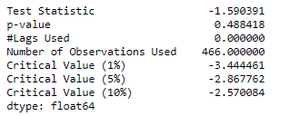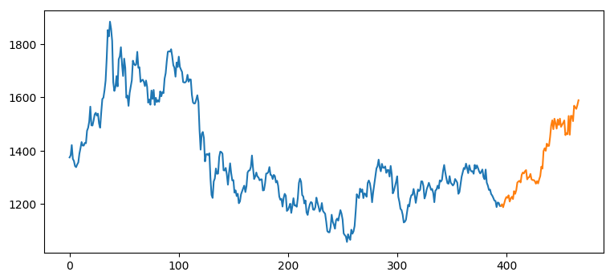

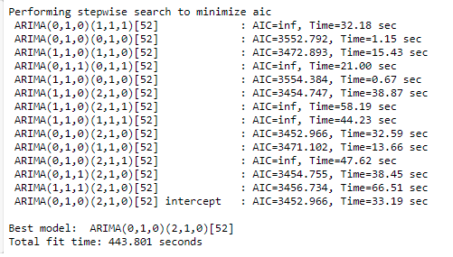

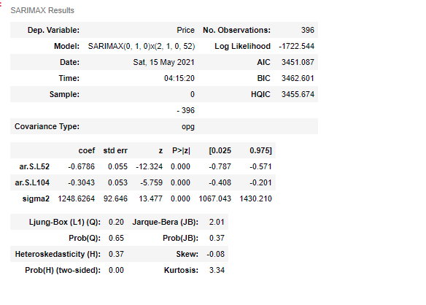

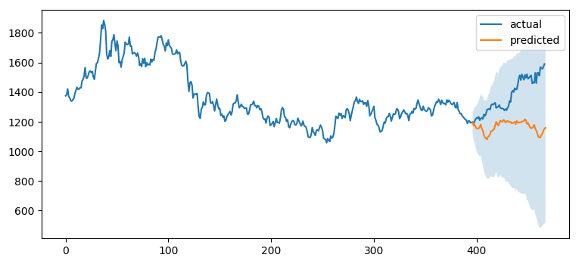

**Gold with Covid - 532 observation**

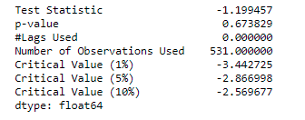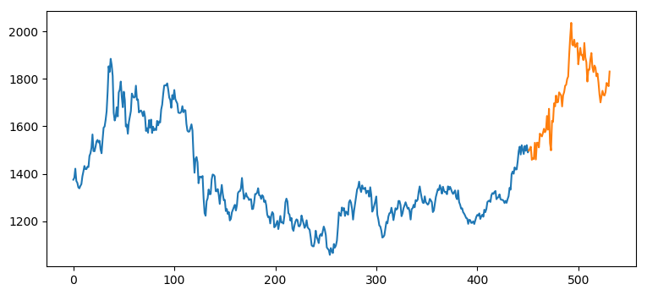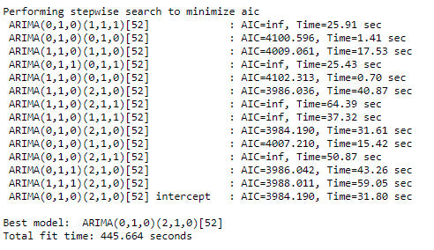

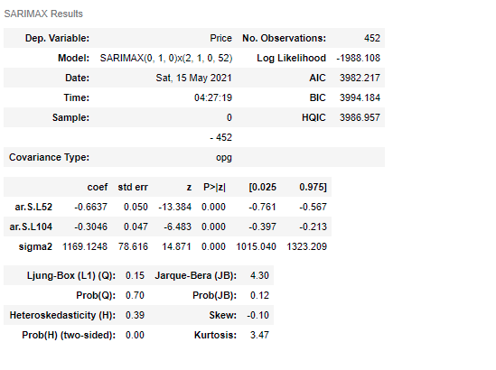

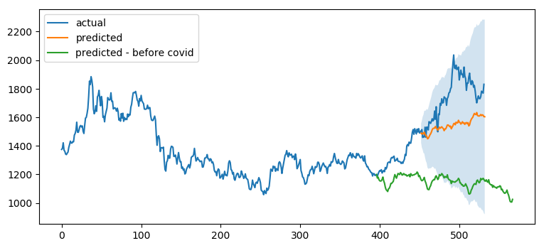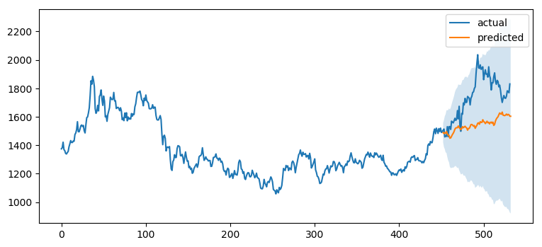

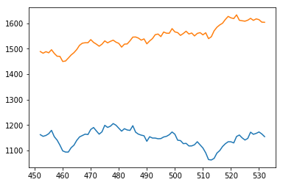

Silver - before covid 468 units

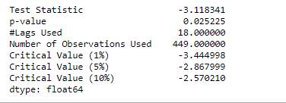

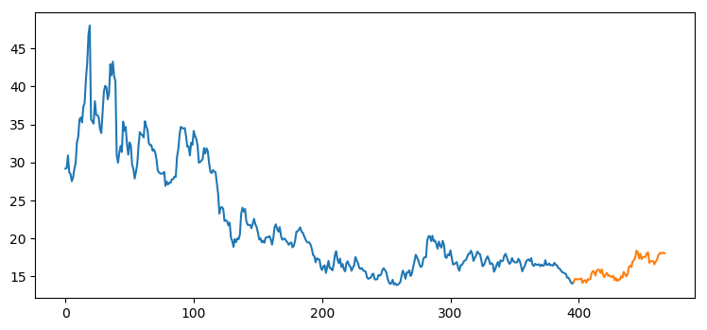

Silver With **covid** 531 unit

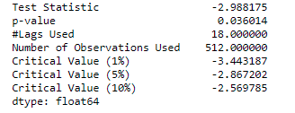

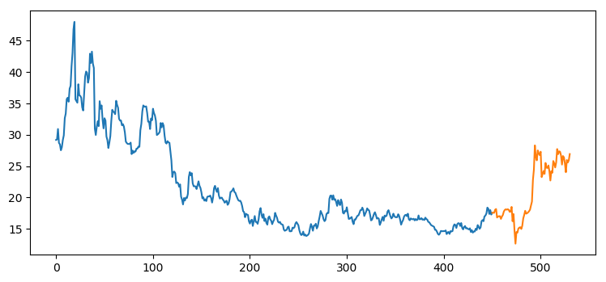

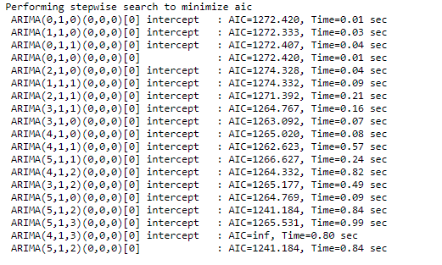

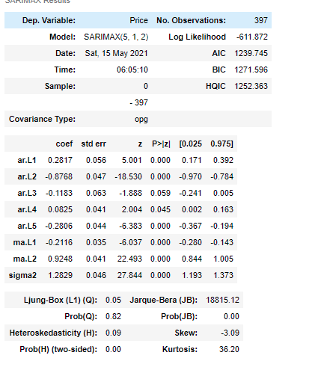

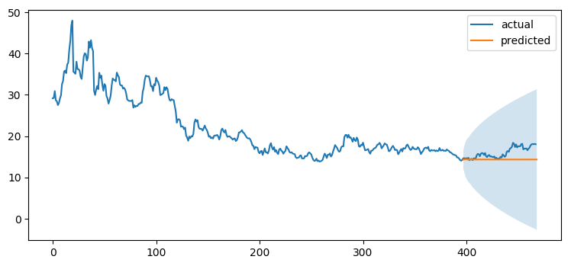

Silver With Covid

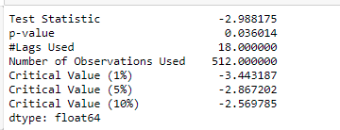

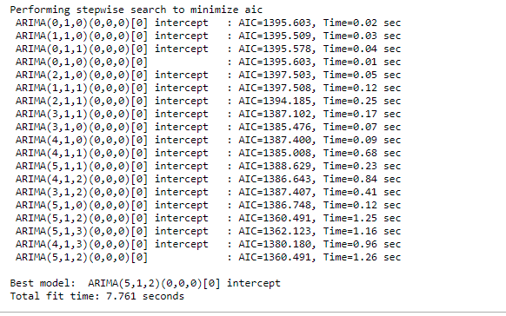

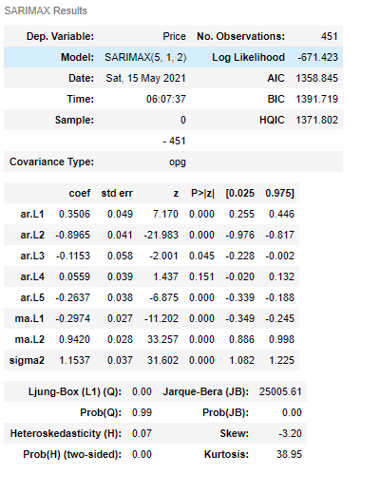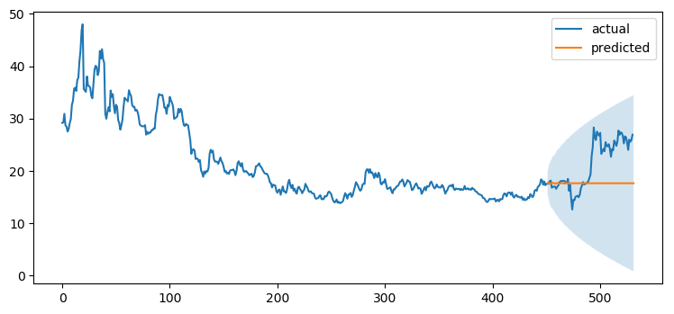

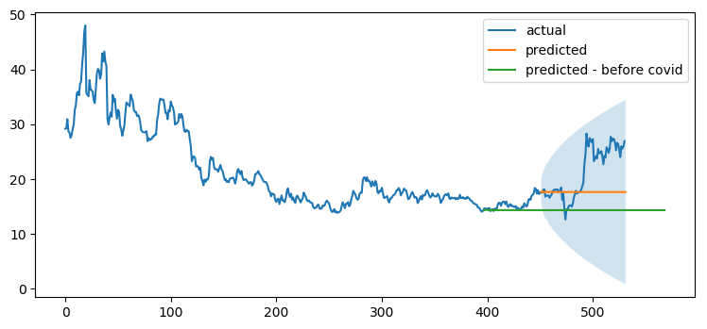

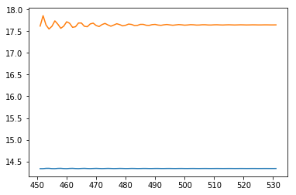

Platinum before Covid – 467 unit

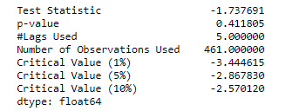

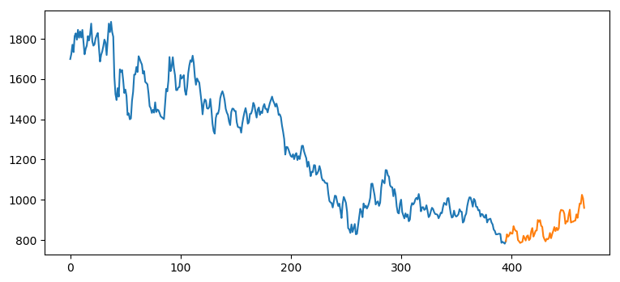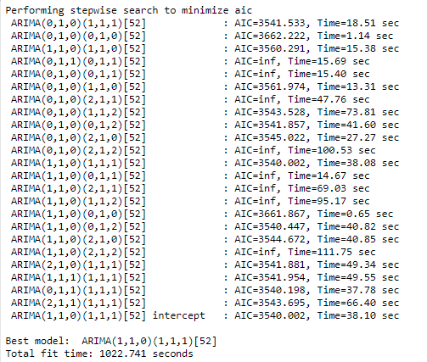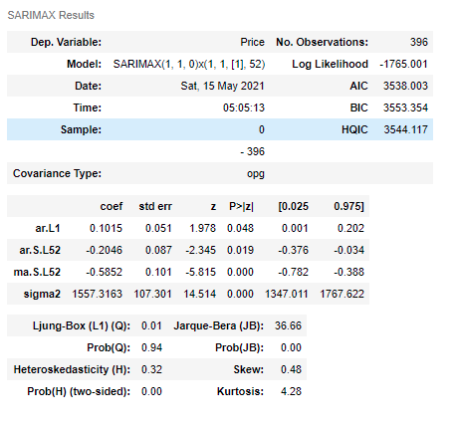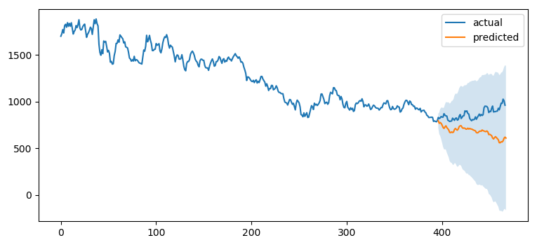

Platinum With covid – 529

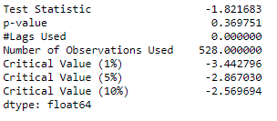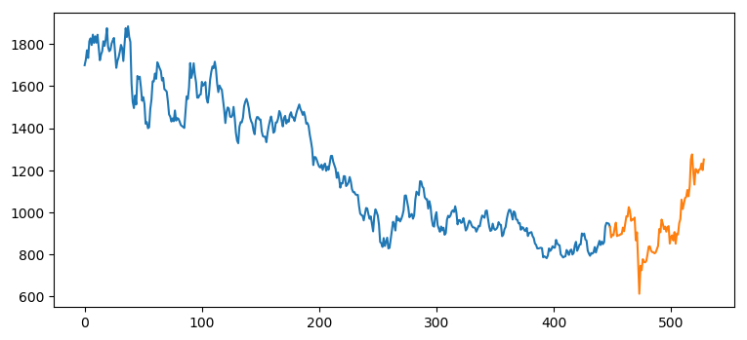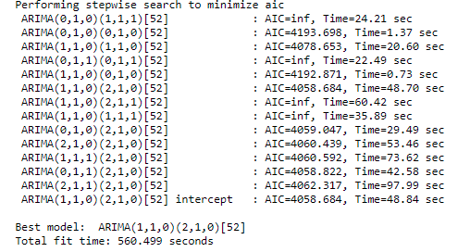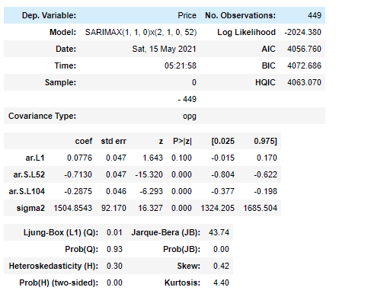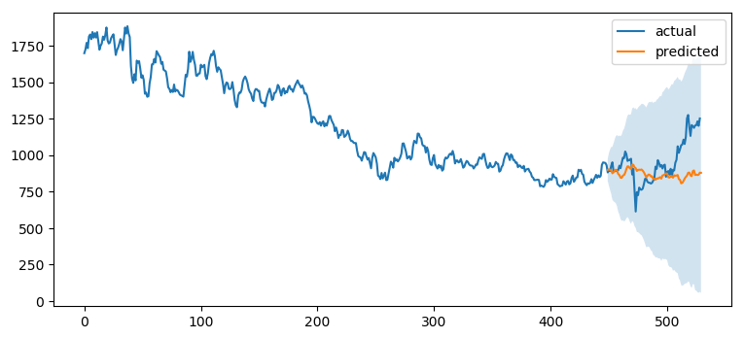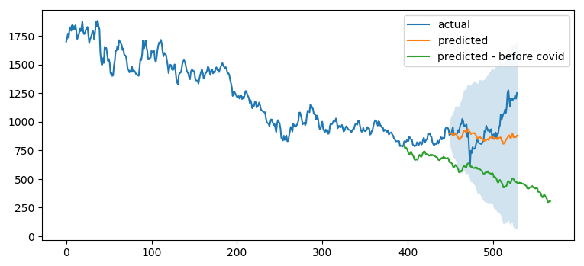

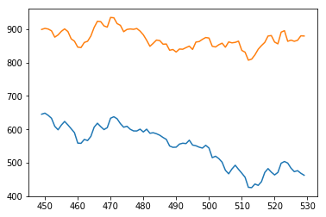

Palladium Before – 467 unit

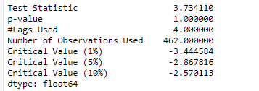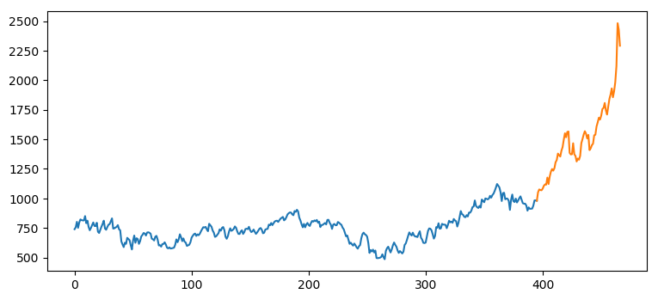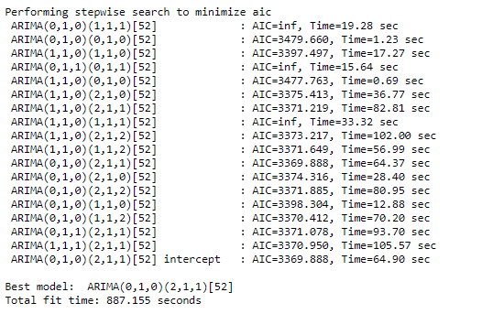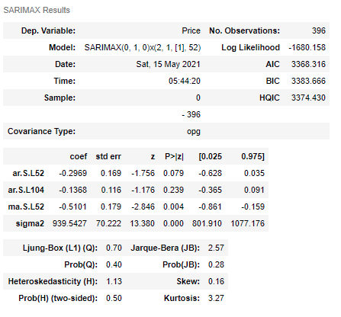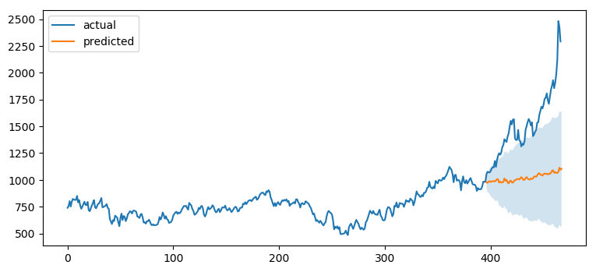

Platinum - with Covid 529 unit

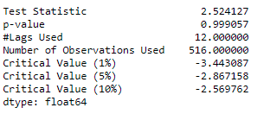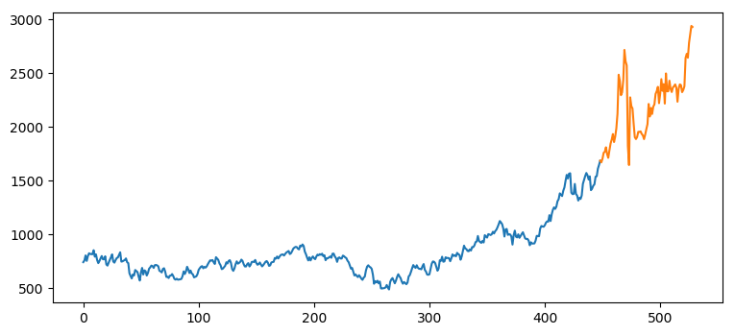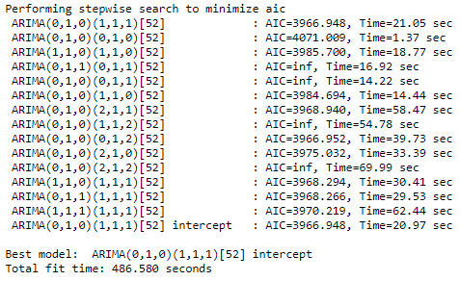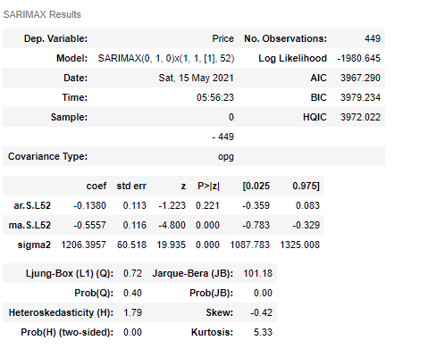

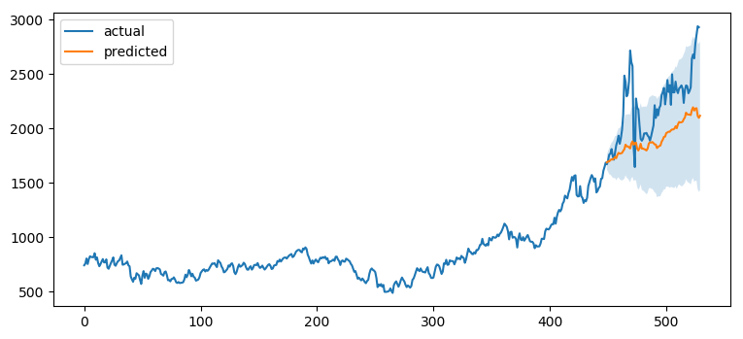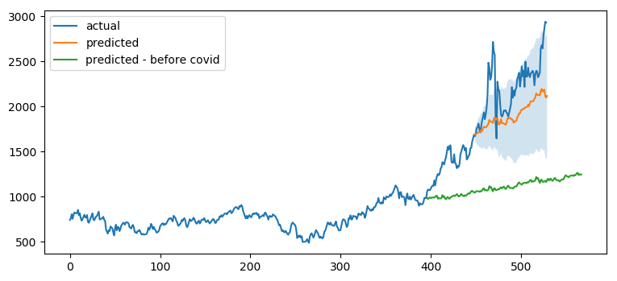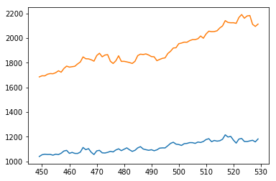

Aluminum – 464 unit before covid

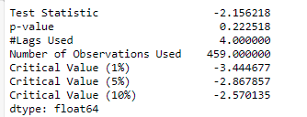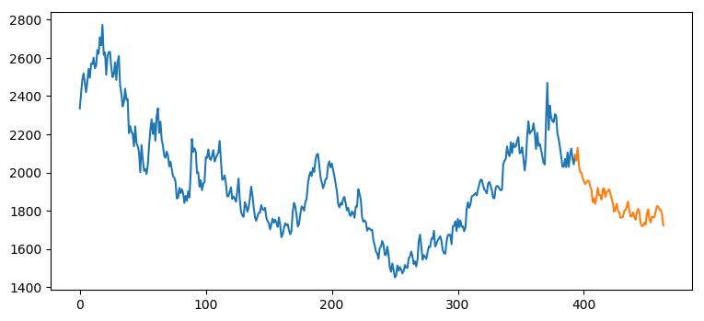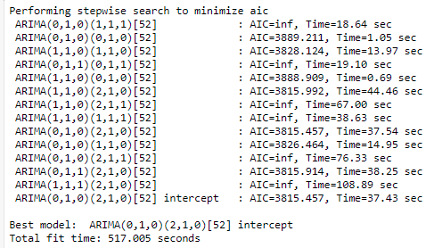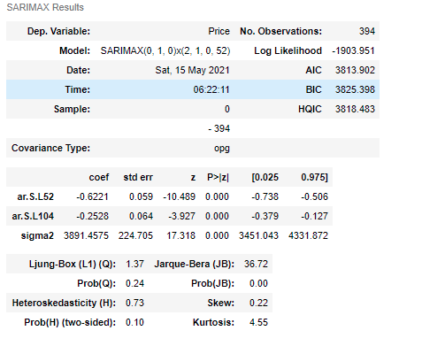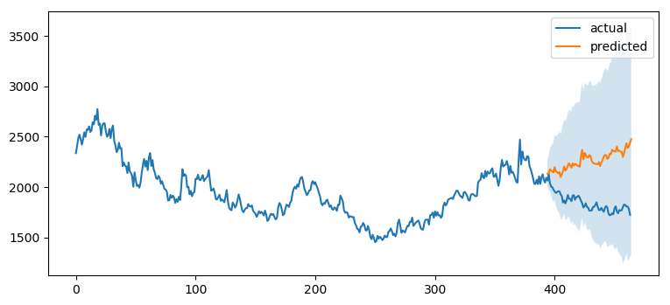

Aluminum - with covid-525 unit

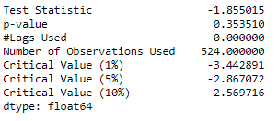

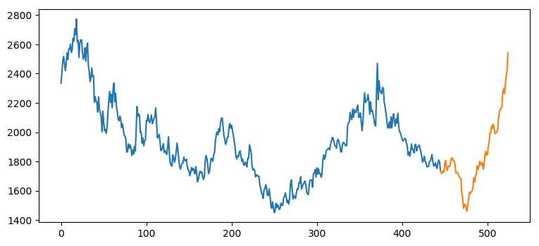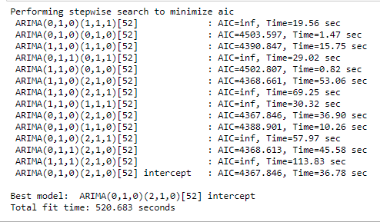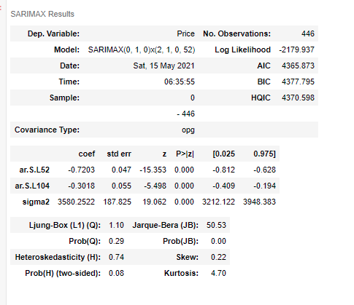

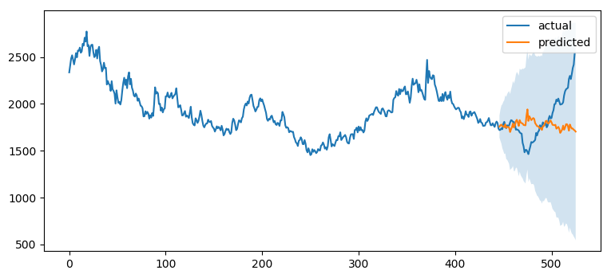

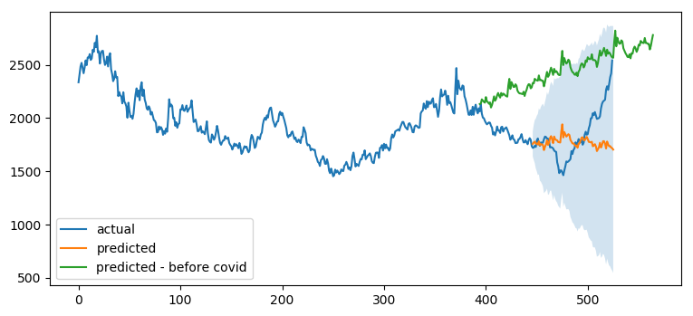

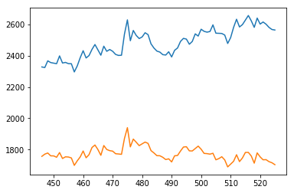

**Cuprum – before Covid 463 unit**

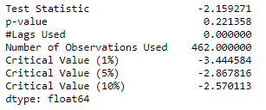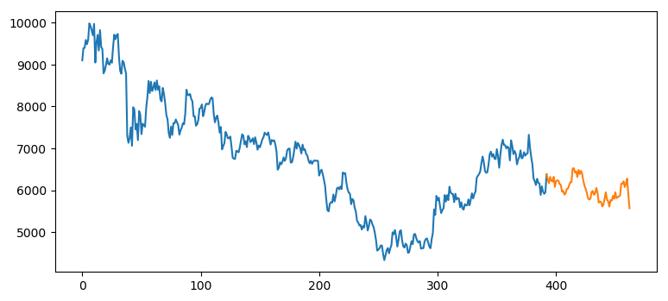

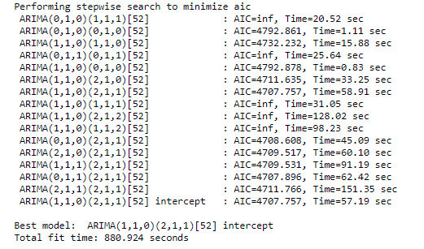

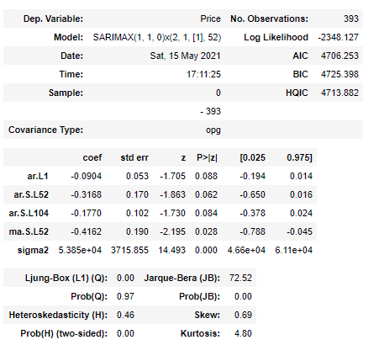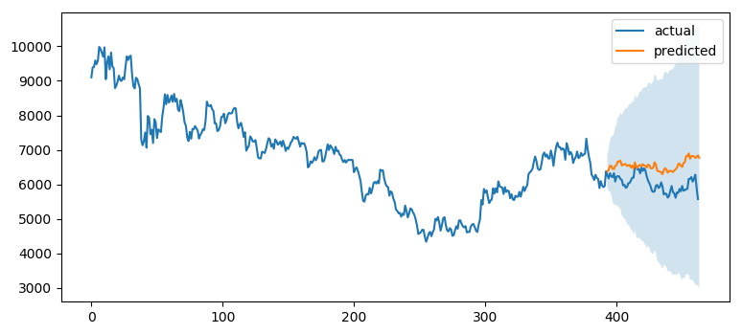

**Cuprum – with Covid 524 unit**

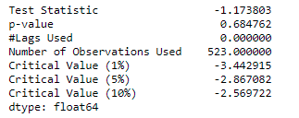

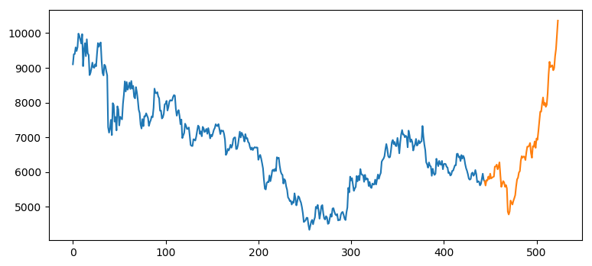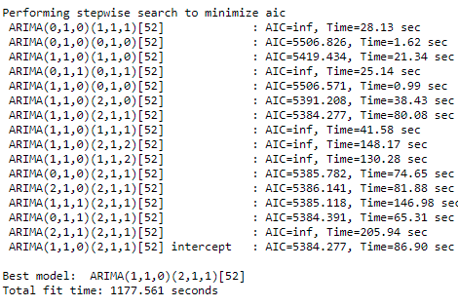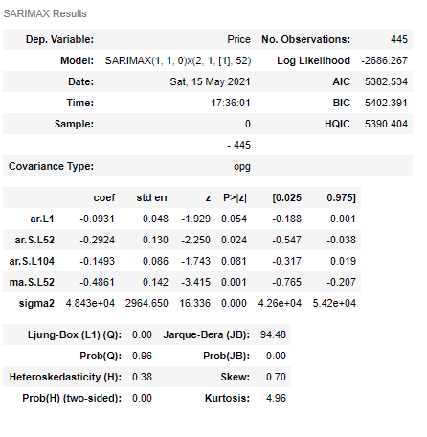

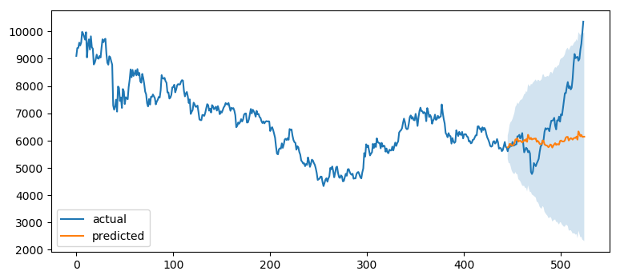

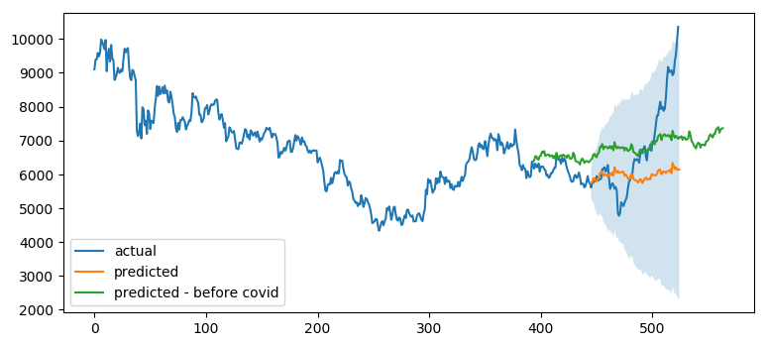

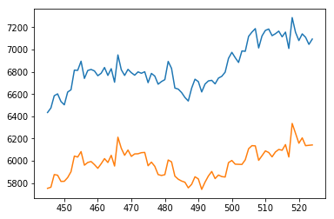

**Nickel - before Covid 420 unit**

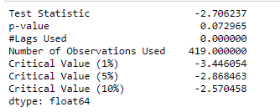

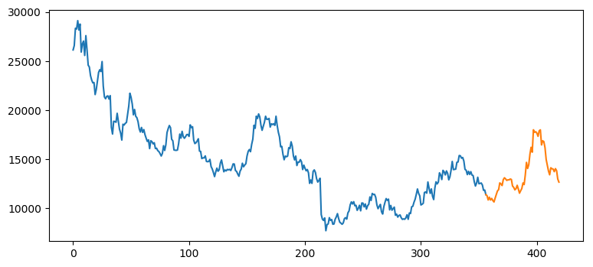

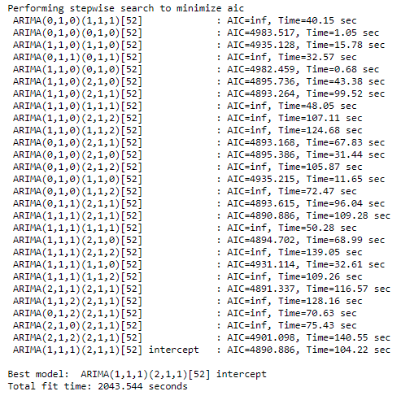

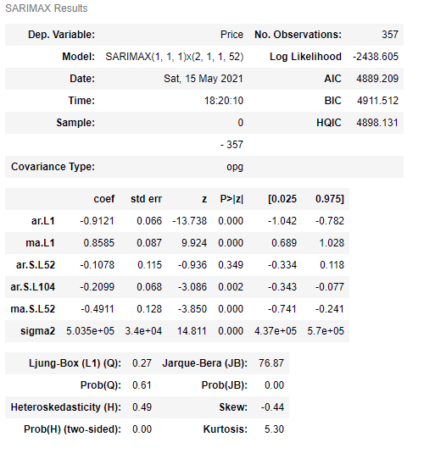

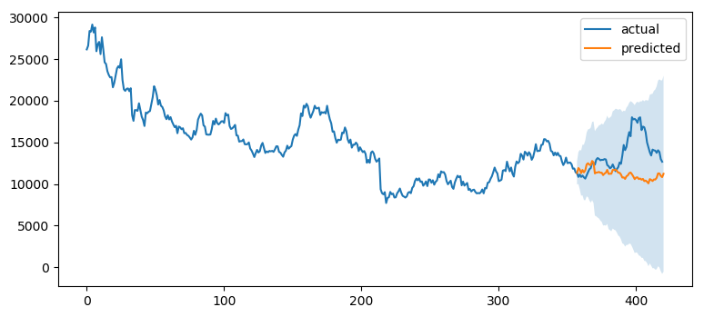

**Nickel - with Covid 481 unit**

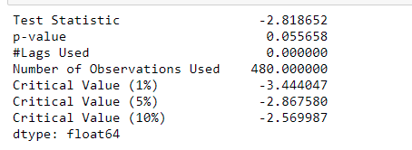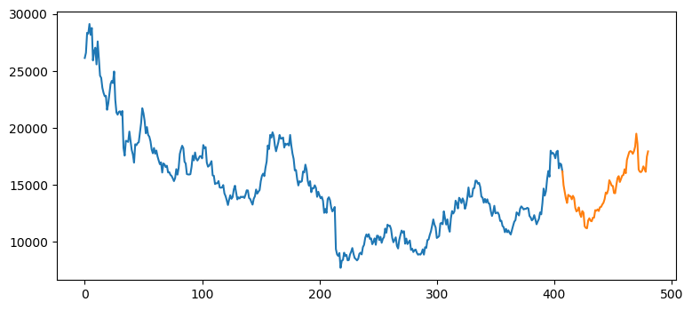

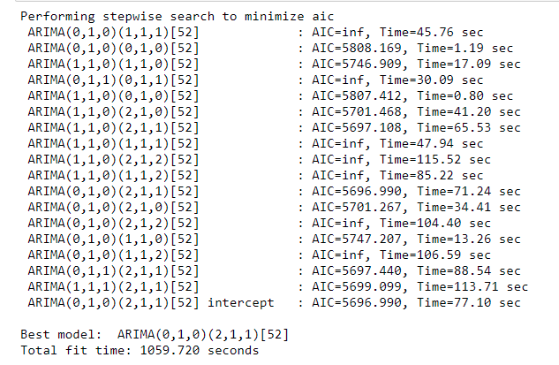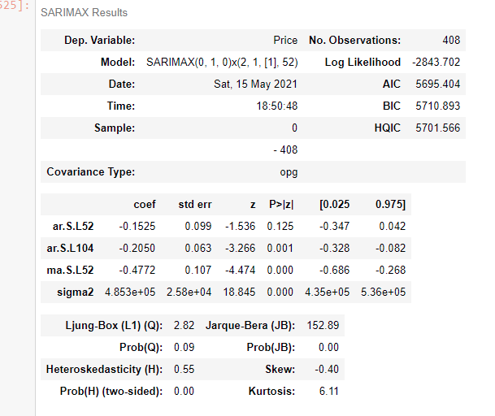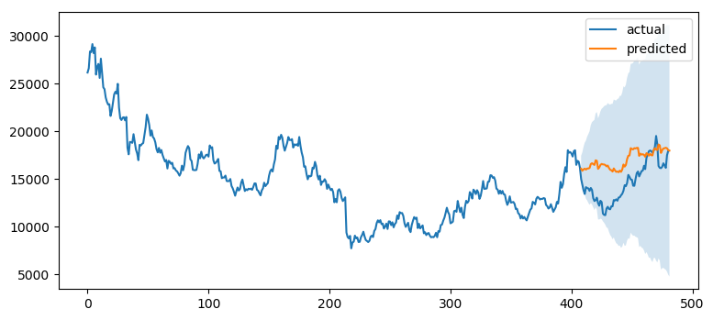

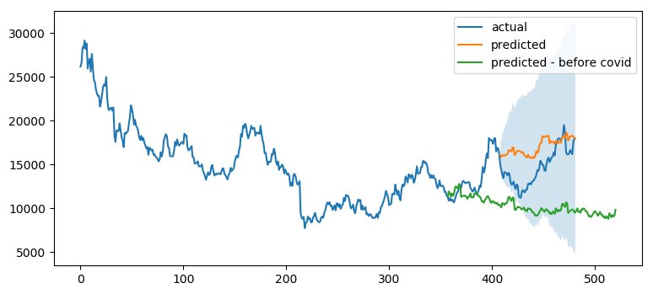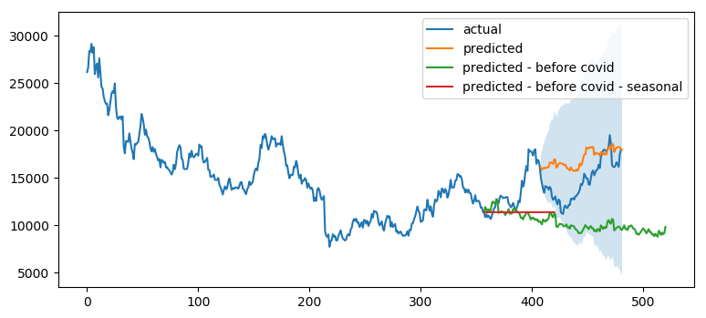

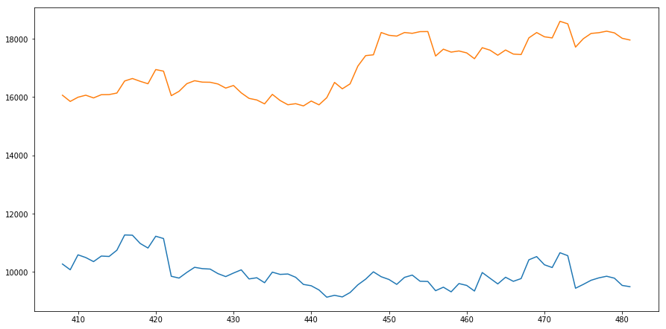

**Plumbum - Before Covid 420**

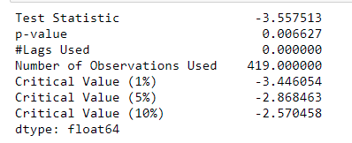

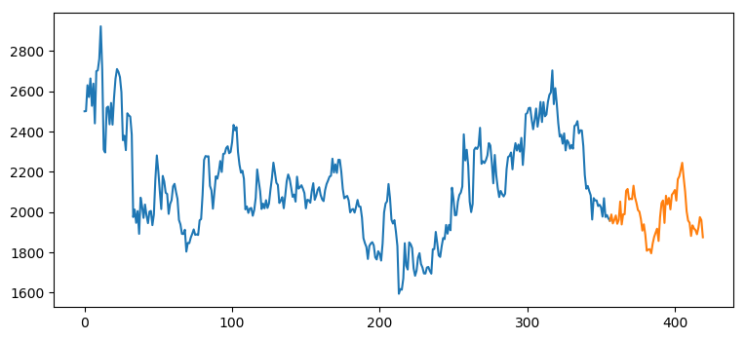

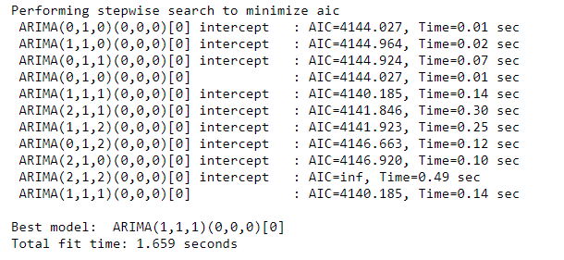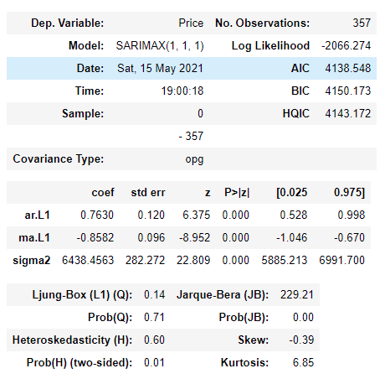

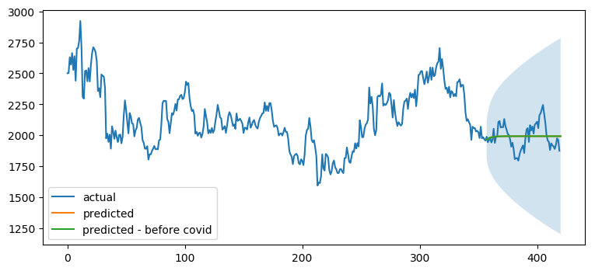

**With covid 481 unit**

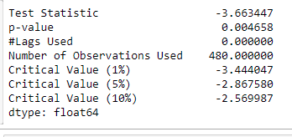

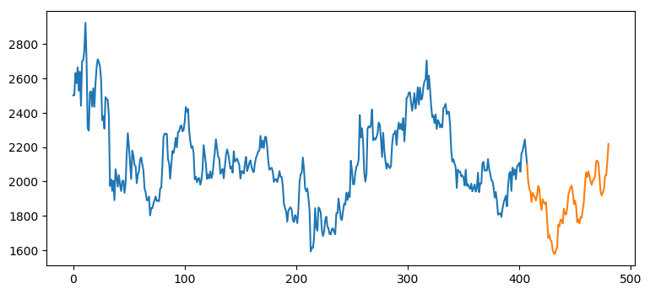

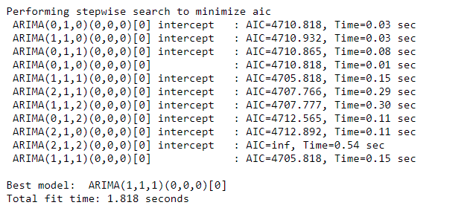

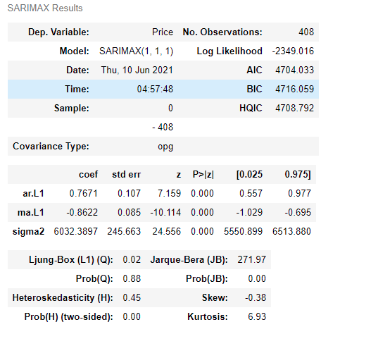

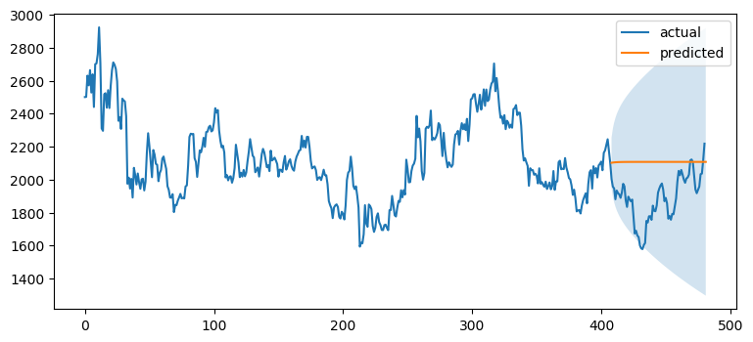

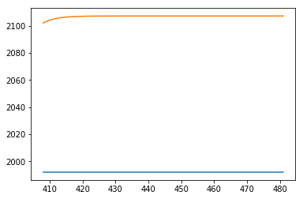

**Zinc - before covid 419**

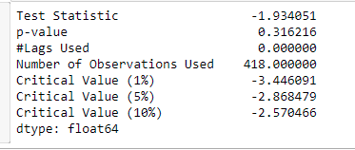

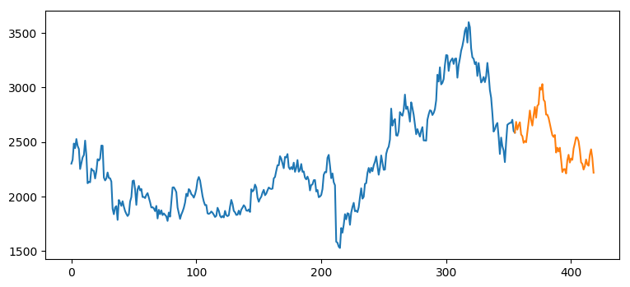

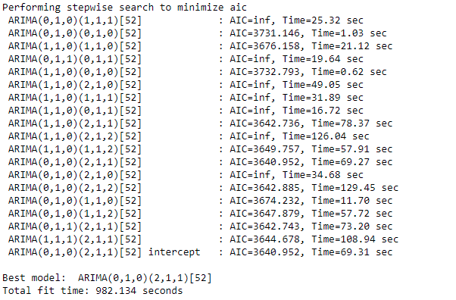

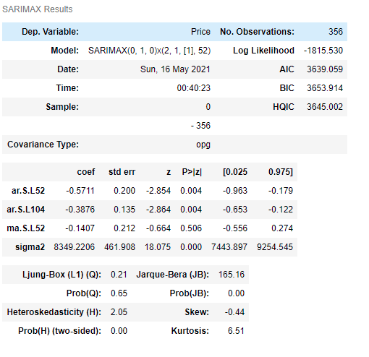

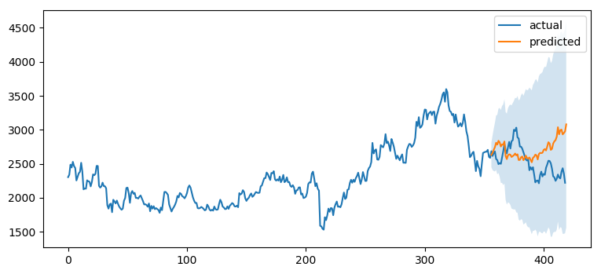

**Zinc – with Covid – 480 unit**

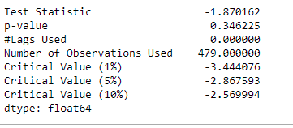

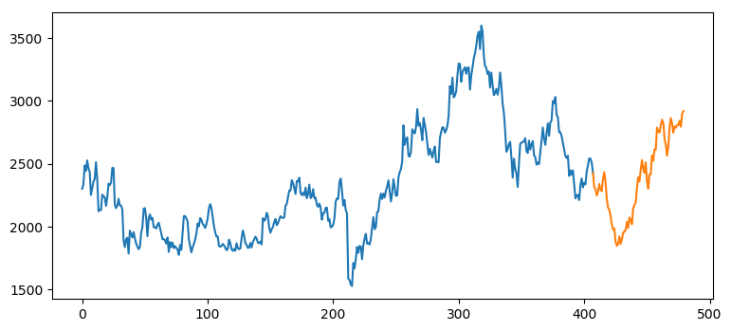

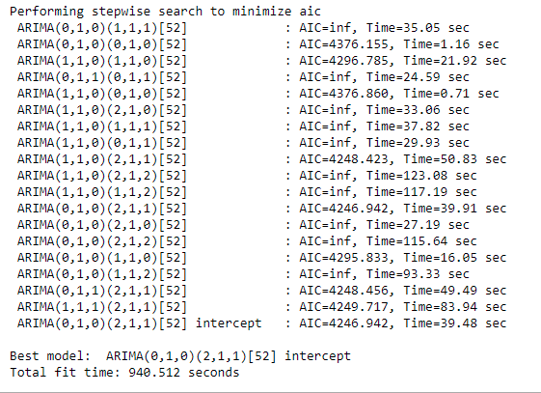

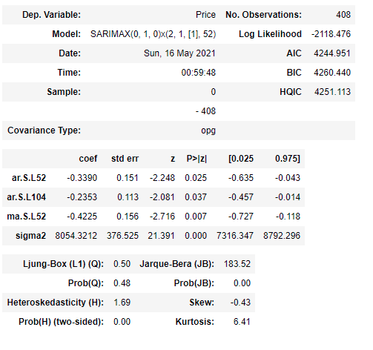

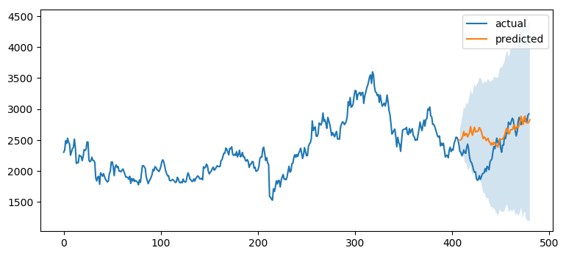

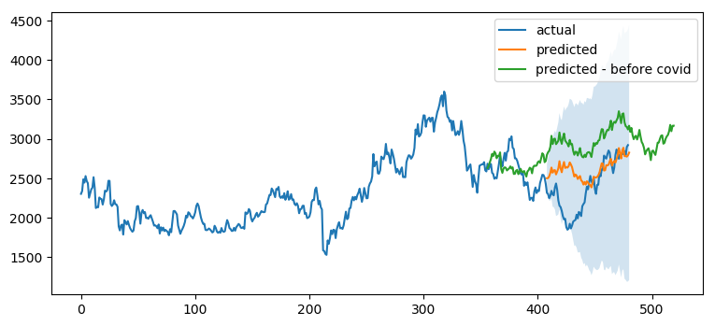

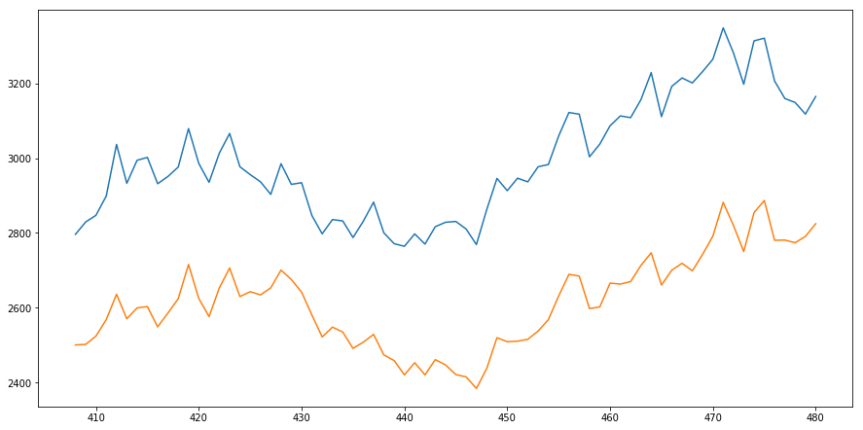

**Stannum - Before Covid 419 unit**

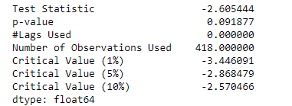

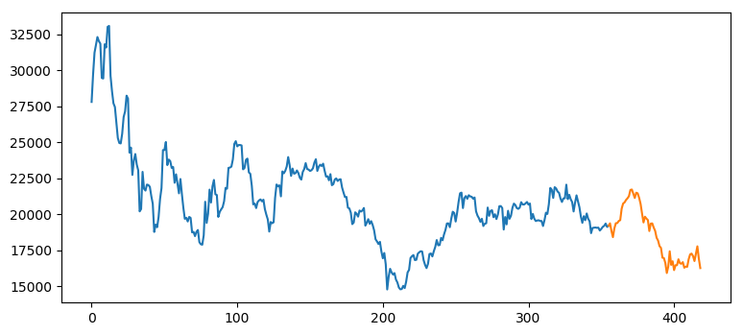

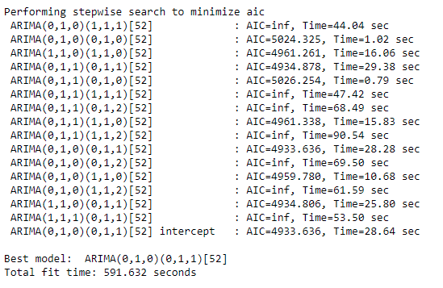

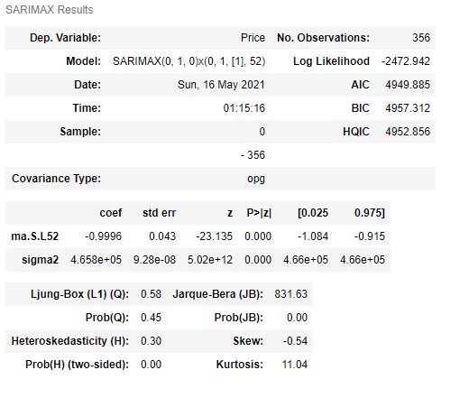

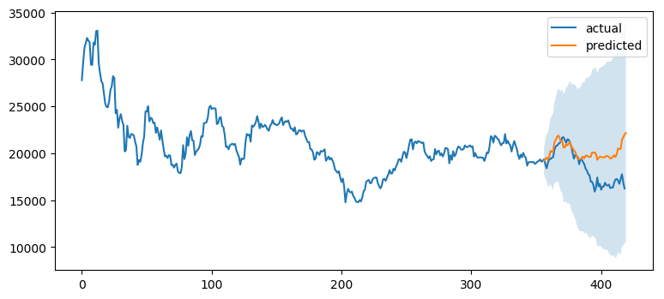

**Stannum - with covid 480 unit**

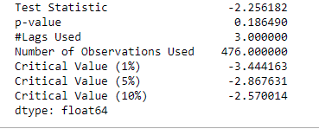

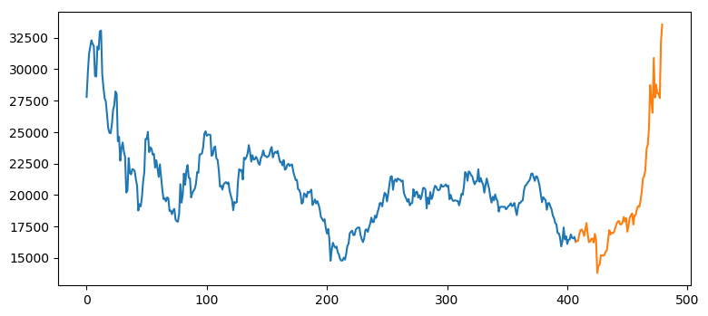

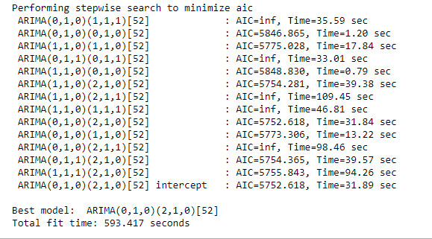

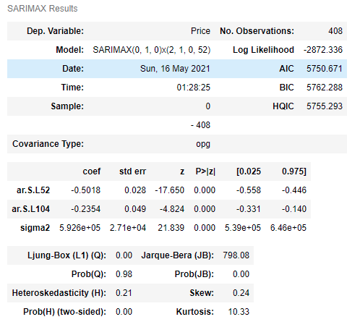

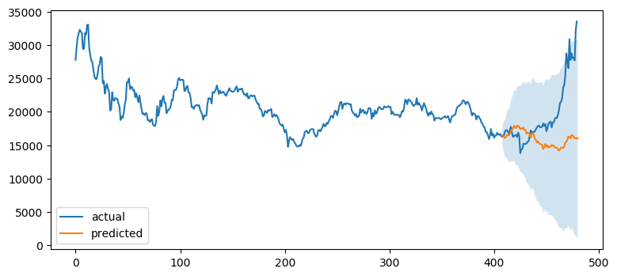

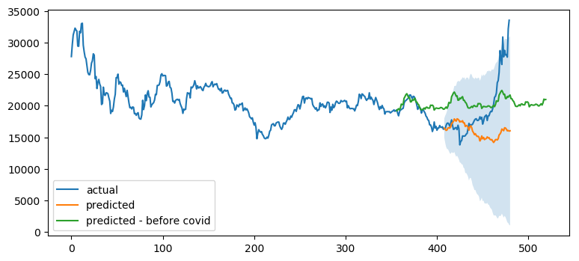

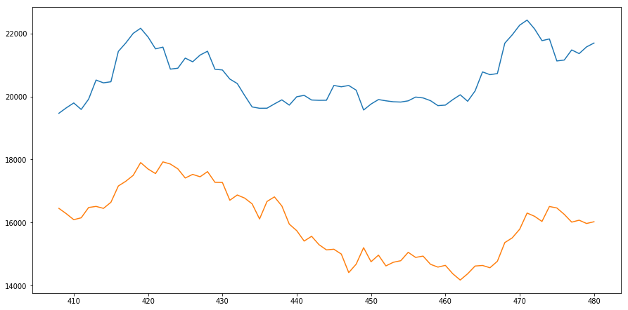

**Metals: Iron Ore - Before Covid 460 unit**

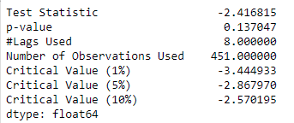

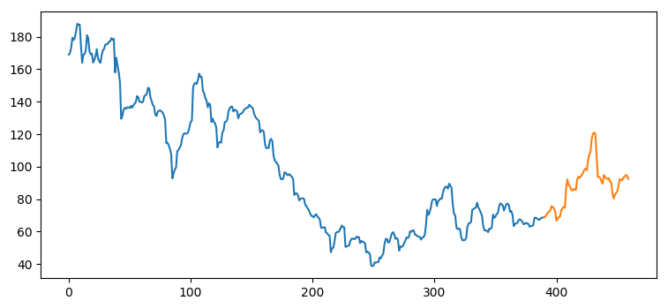

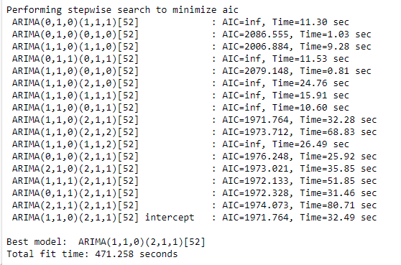

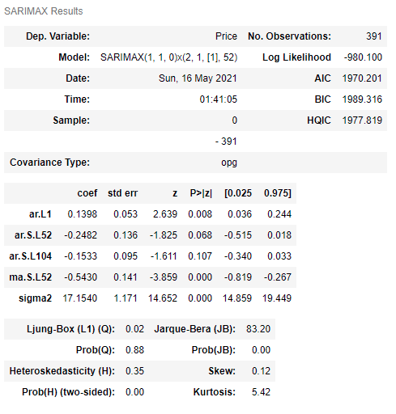

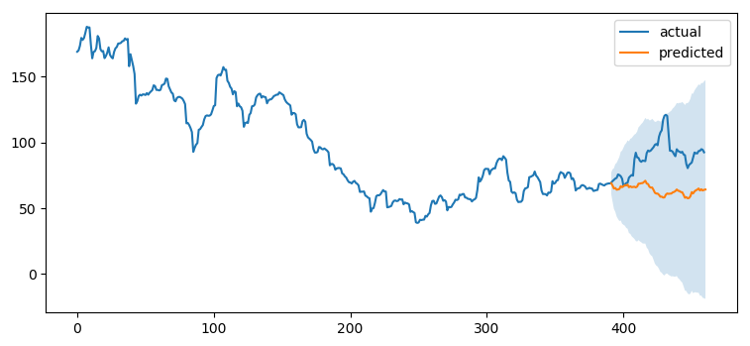

**Iron Ore - With Covid 515 unit**

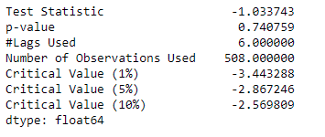

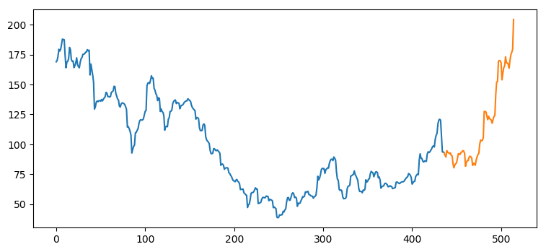

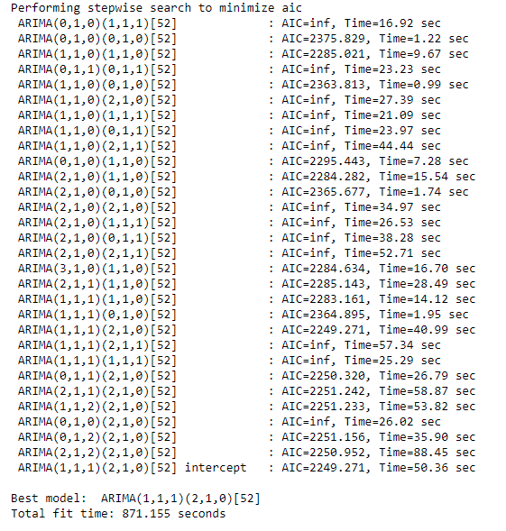

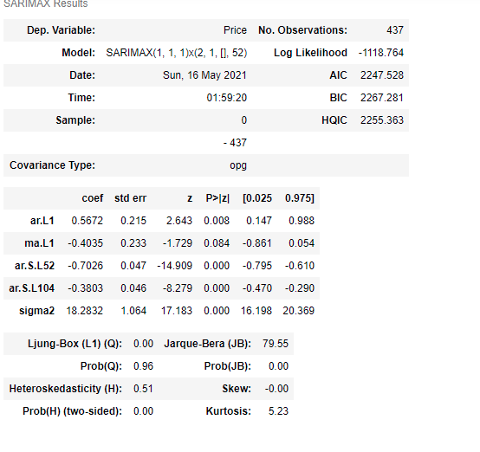

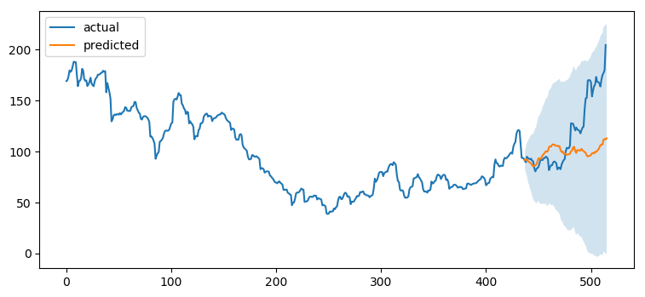

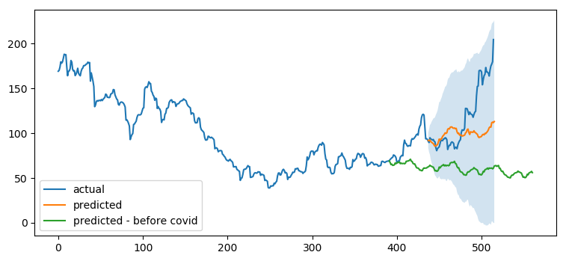

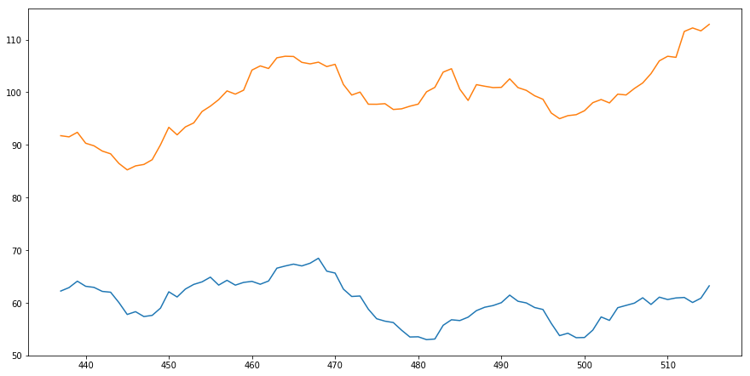

**Brent oil - before Covid 470 unit**

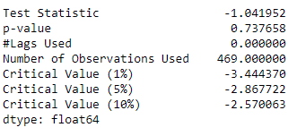

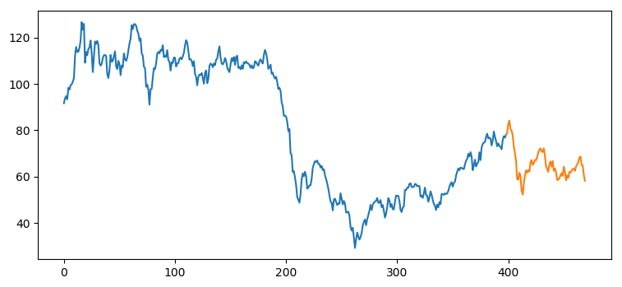

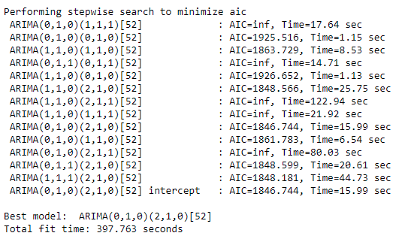

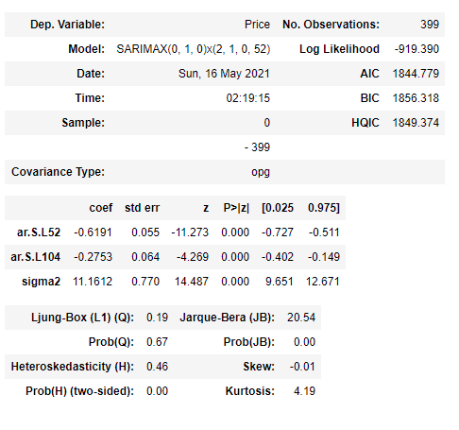



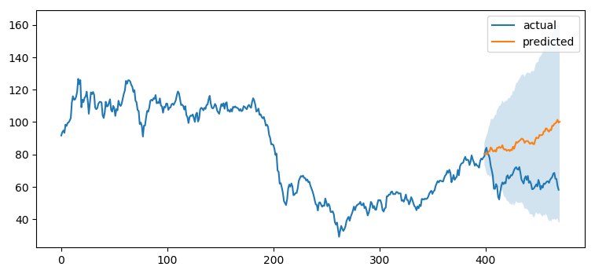

**Brent - With Covid 532 unit**

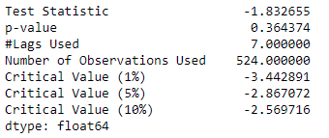

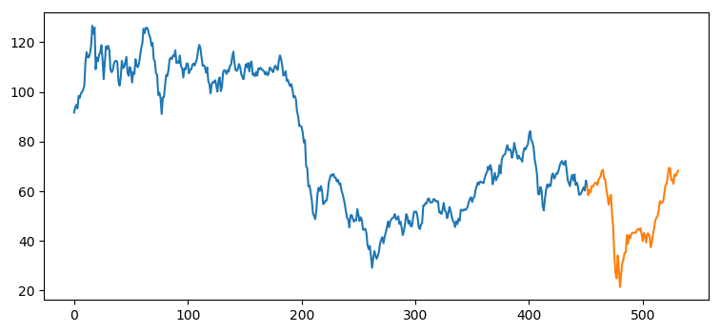

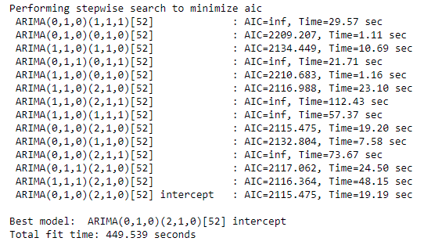

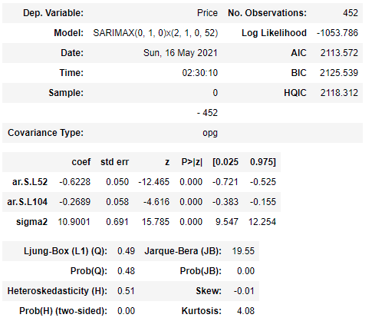

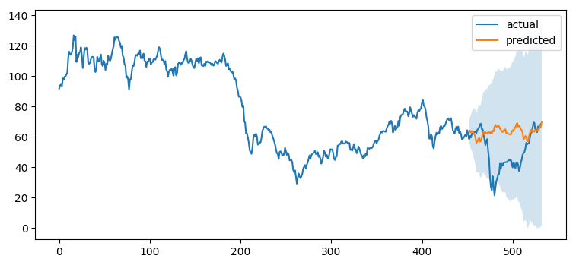

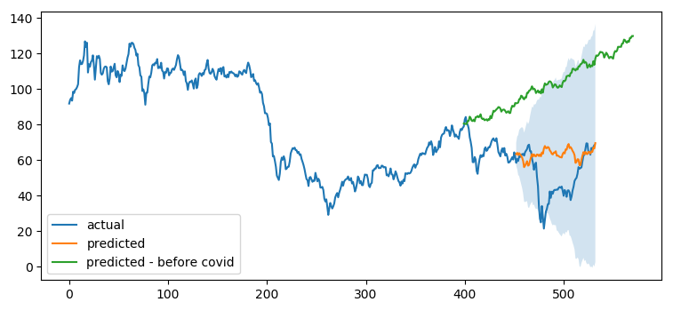

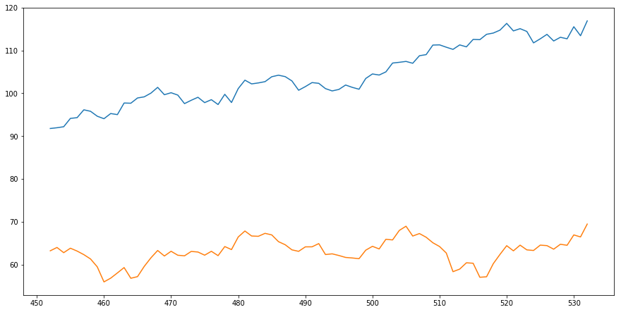

**Coal - Before – 434 unit**

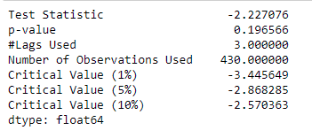

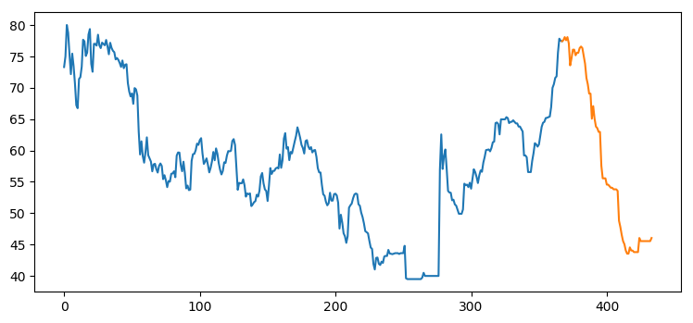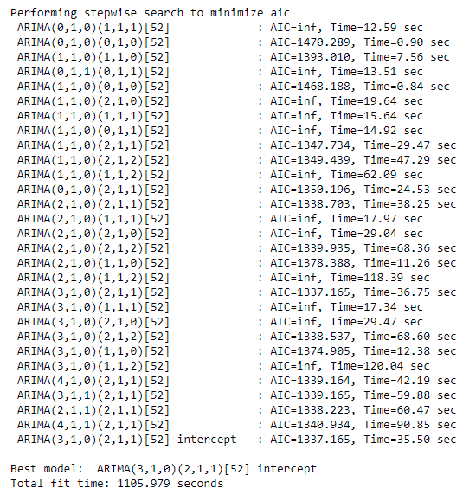

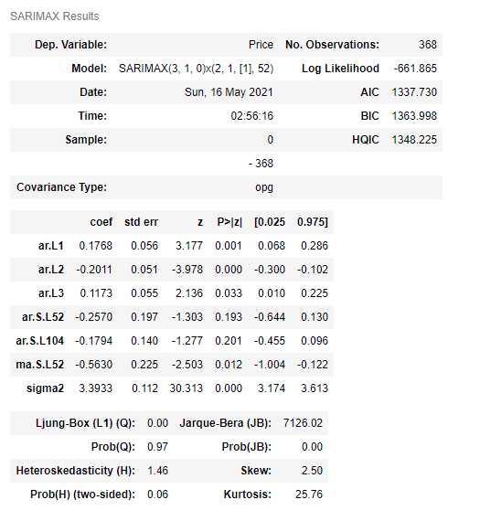

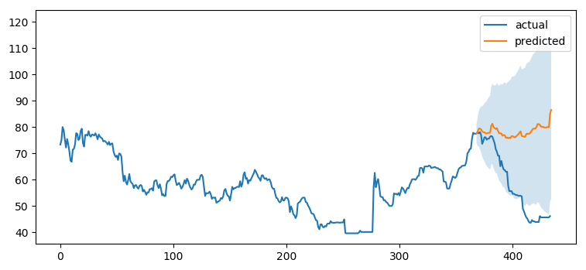

**Coal - with Covid 489 unit**

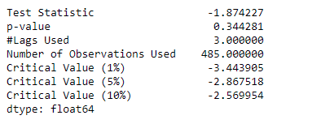

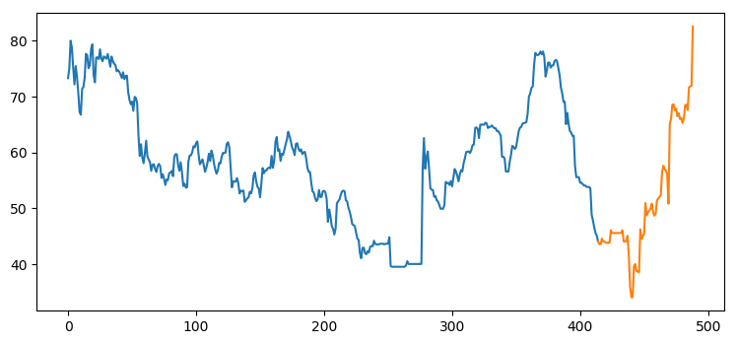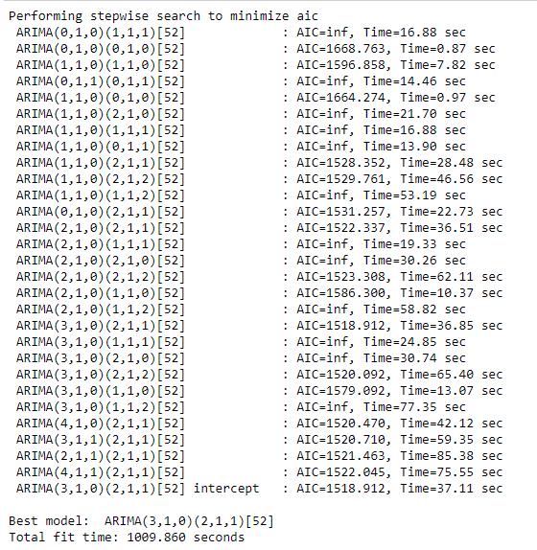

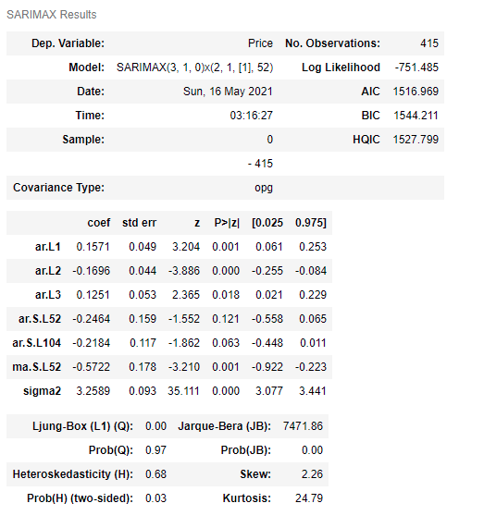

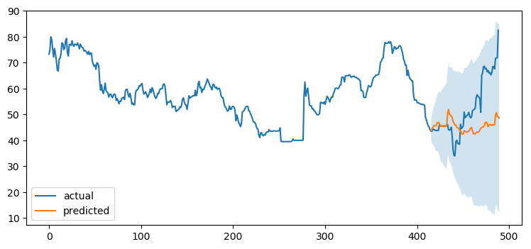

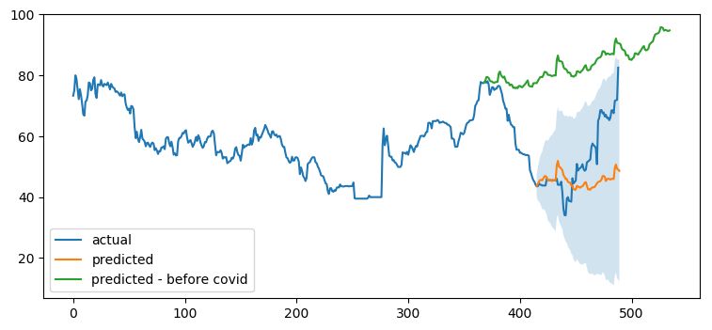

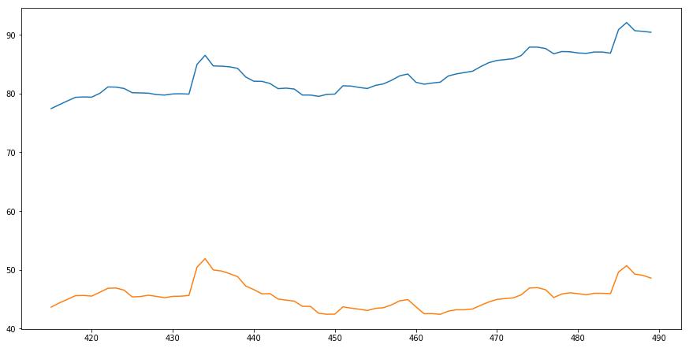

**WTI oil - Before Covid 469 unit**

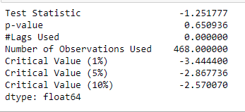

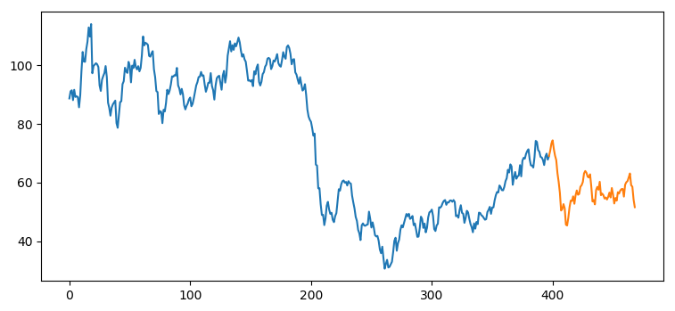

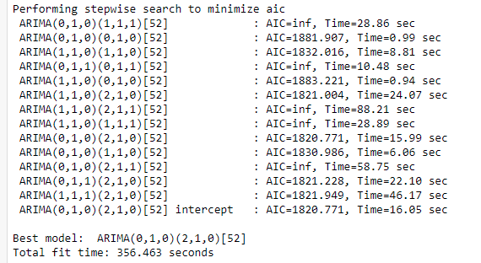

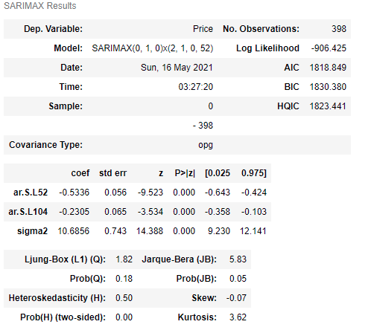

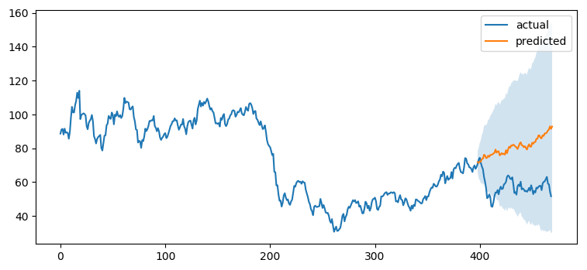

**WTI - with covid 531 unit**

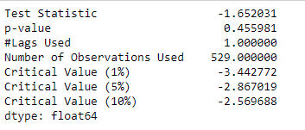

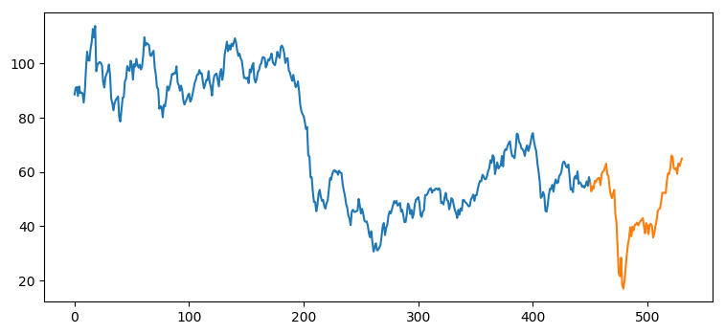

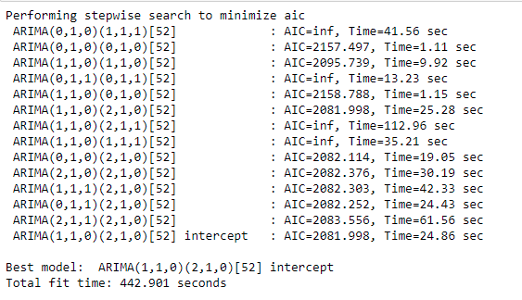

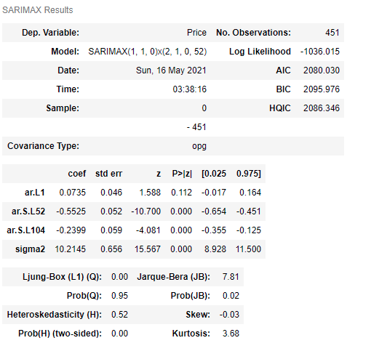

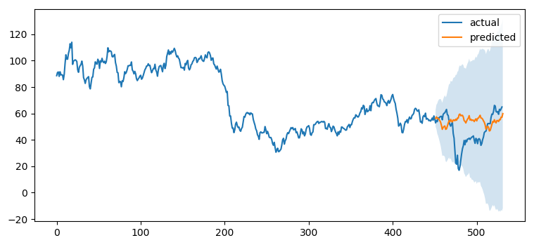

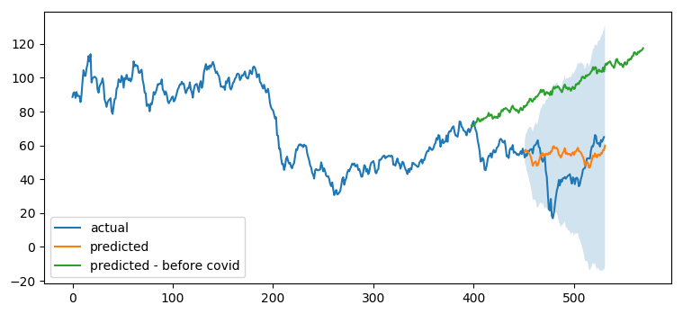

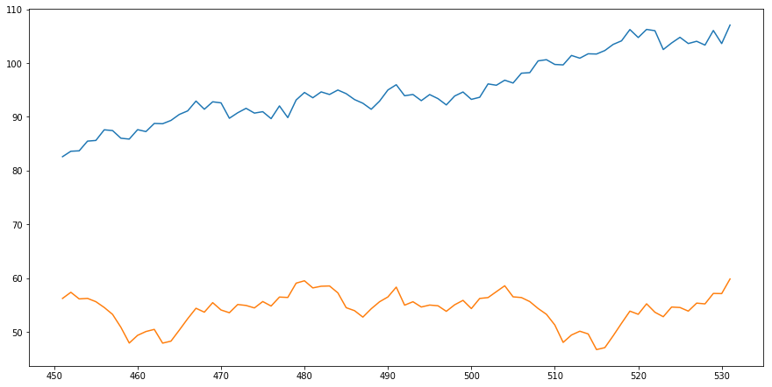

**Uranium - Before covid – 447 unit**

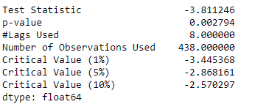

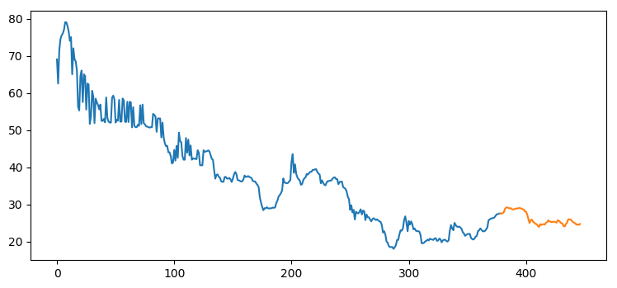

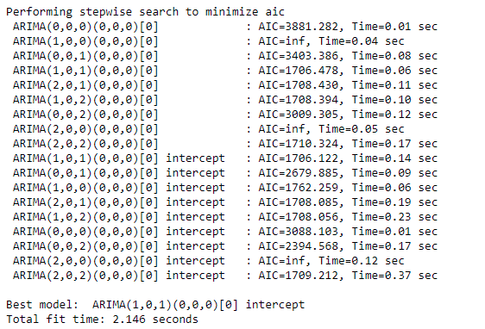

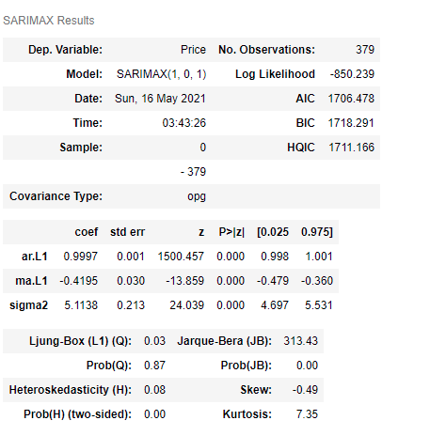

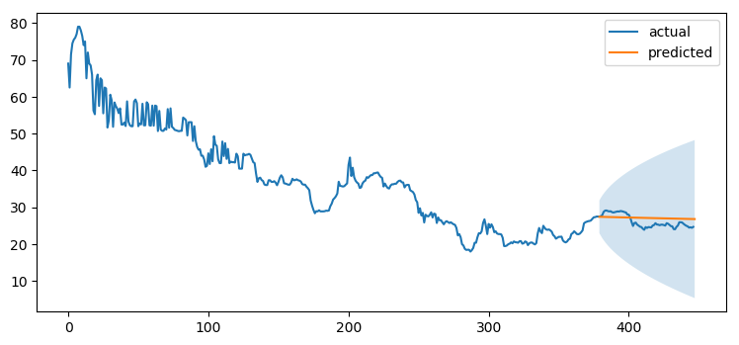

**Uranium - with Covid 475 unit**

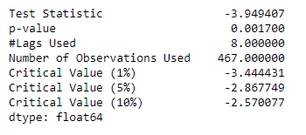

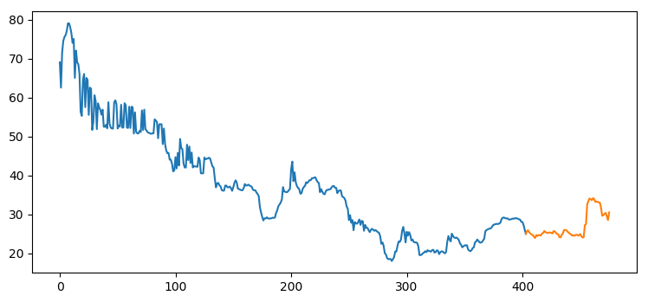

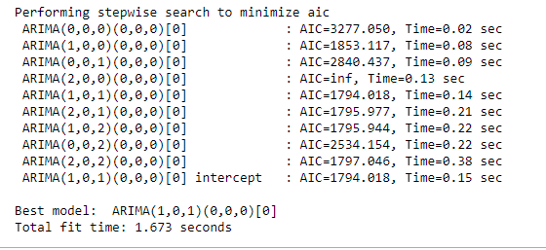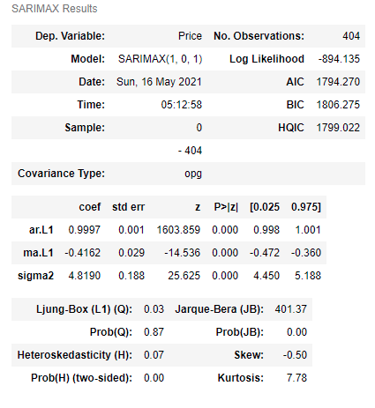

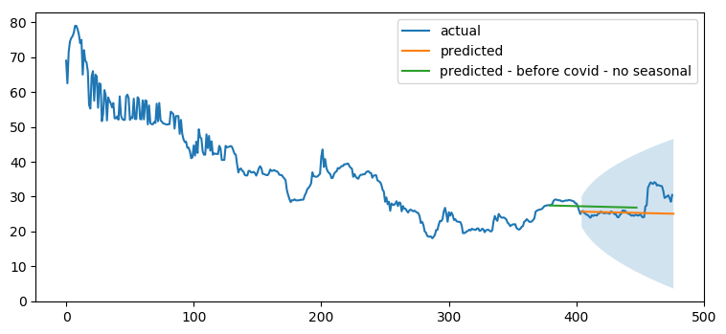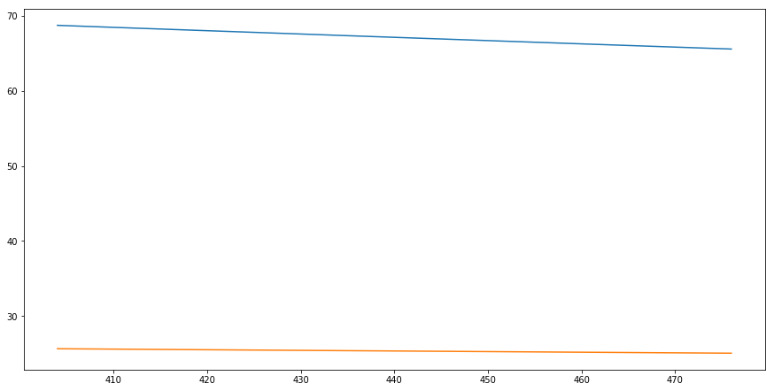

**Gas - before Covid 469**

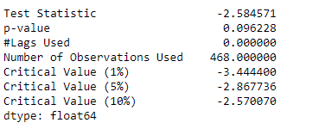

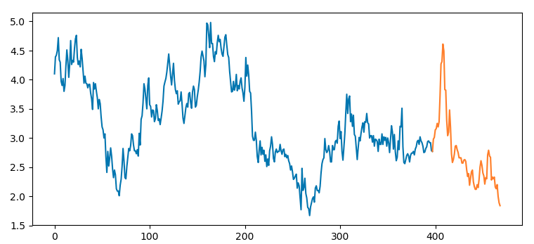

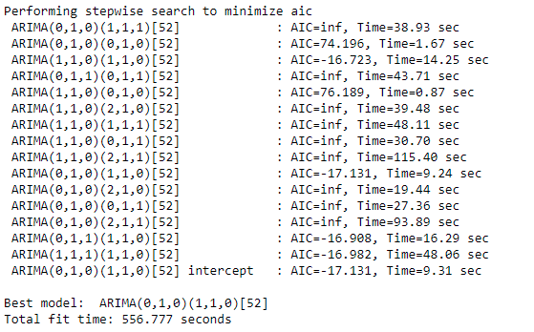

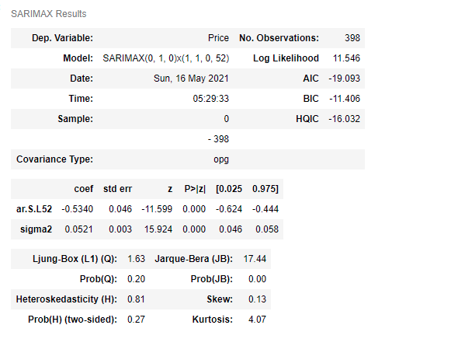

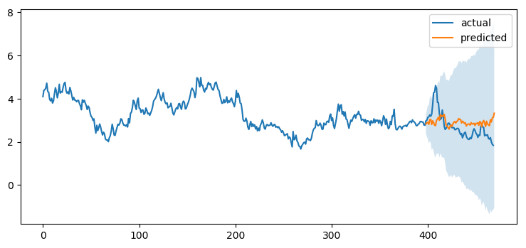

**Gas with covid – 531 unit**

